FEED BACK ACTIVITY

Science

Year 2

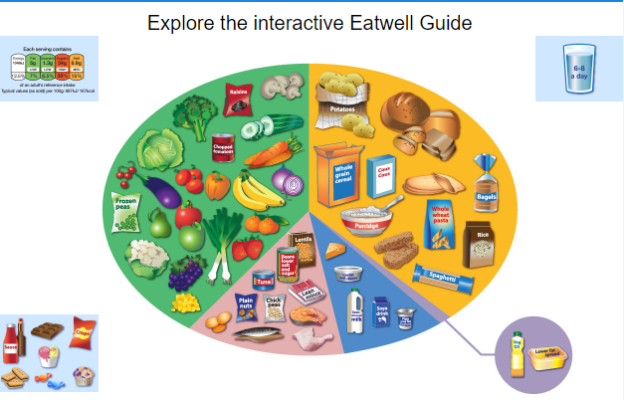**Food Detective Project- the importance of eating the right amount of different types of food**

In YEAR 2 the children learn about the five food groups and understand that each group has a different function in the body.

Fruit and vegetables are a source of vitamins and minerals which are important for many functions in the body including having a healthy immune system. We are advised to have five portions of a variety of fruit and vegetables each day.

Carbohydrates (starchy foods including potatoes, rice, pasta, bread) make up around a third of everything we eat. They are important for providing us with energy and fibre (if we choose whole-grain options, or leave the skin on potatoes).

Protein (meat, fish, eggs, beans, nuts) is essential for growth and repair in the body. They also provide vitamins and minerals.

Dairy products are also good sources of protein and they provide calcium which is important for healthy bones.

Sweets and oils (fats and sugars) also provide energy but most people have too much of these which is unhealthy.

Key Vocabulary:

dairy, carbohydrates, protein, sweets & oils, fruits & vegetables

|  |  |
| --- | --- |
| Task 1 | What is your favourite food?  Draw and label. |
| Task 2 | Find out about the Eatwell plate.  Use:   * [www.nhs.uk/live-well/eat-well/the-eatwell-guide/](http://www.nhs.uk/live-well/eat-well/the-eatwell-guide/) * Poster available * Facts sheets about what you should eat * Own research- books, internet   Have a go sorting the different foods onto an Eatwell plate. Or alternatively draw your own food.  Why have scientists put food into these groups? |
| Task 3 | Keep a food and water diary for the week.  Examples are on the web blog.  Alternatively, create your own little book and create a food diary. Include, pictures, labels and what food group it belongs to. |
| Task 4 | Create a healthy lunch box.  Refer to the pick and mix sheets to support the activity.  You can present you healthy lunch box in any way you want:   * Drawing/poster * Pictures from the internet * Real food * Video * Include detail about which food groups and why you have included it |

After completing the Science food detective project send me your work on SEESAW. You can send any of the Science tasks 1 to 4. If possible I would love to see Task 4!

I am looking forward to seeing what you create. How healthy are you?!!