## 

## **Ice Cream**

July 1st was officially 'Creative Ice Cream Flavour Day’!

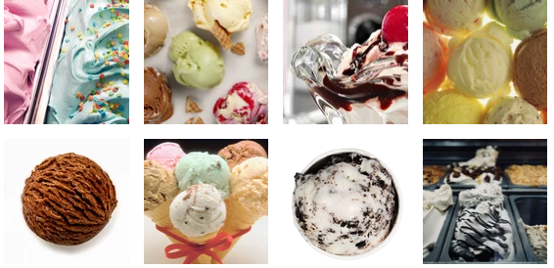

1. Look at a range of pictures of Ice Cream or real Ice Cream if you have it!
2. Create a list of ideas about all about Ice Cream.

Look at some of my ideas:

|  |  |  |
| --- | --- | --- |
| Greatest  Coldest  Frostiest | Scummiest  Yummiest  sweetest | Superb  Tasty  Delicious  Exquisite  Incredible  Amazing  wonderful |
| Homemade  Colourful  Dripping  Melting  smooth | Velvety  Heavenly  Gooey  Lumpy  Sugary/sweet | Scrummy  Silky  Frozen  Creamy  Glistening |
| Soft  Runny  swirls | Toppings  sprinkles  Flake  Choc-chips | Cone  Tub  Scoop  Flavours |

1. Now write your own poem using your ideas.
2. Illustrate your poem.
3. If possible create your own Ice Cream Sundae or a simple two scoops and enjoy!!

