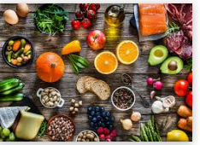

English Tasks all about Food.

|  |  |
| --- | --- |
| **Task 1-**  **To use adjectives to describe** | Watch this You tube video:  <https://www.youtube.com/watch?v=tgxsX4fRTuQ>  The book is Eating the alphabet by Lois Ehlert  Create your own A to Z of food book.  Draw each food and add a caption underneath including adjectives to describe.  Example:   1. Juicy, green pears ripe and ready to pick. 2. Crunchy, fresh baguette layered with yummy cheese and tasty ham. |
| **Task 2-**  **To read accurately and recall information** | Read Where does chocolate come from?  Write an account/ bullet points of where chocolate comes from in your own words. |
| **Task 3-**  **Create your own poem.** | July 1st was officially 'Creative Ice Cream Flavour Day.  Refer to Ice Cream activity file on the blog to create an Ice cream poem! |