Maths Challenge Year 2

Amber Challenge

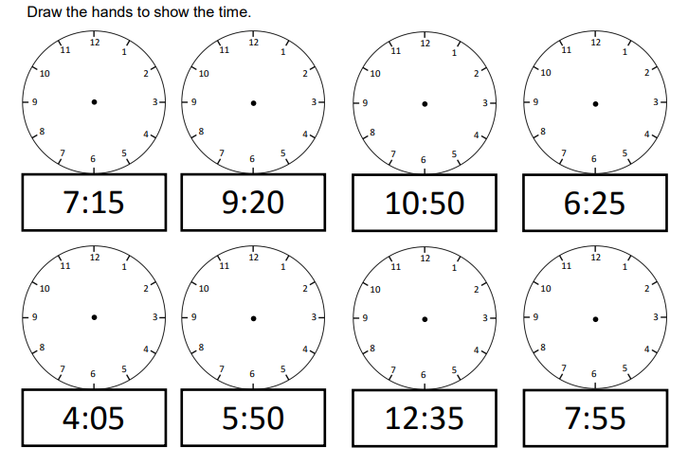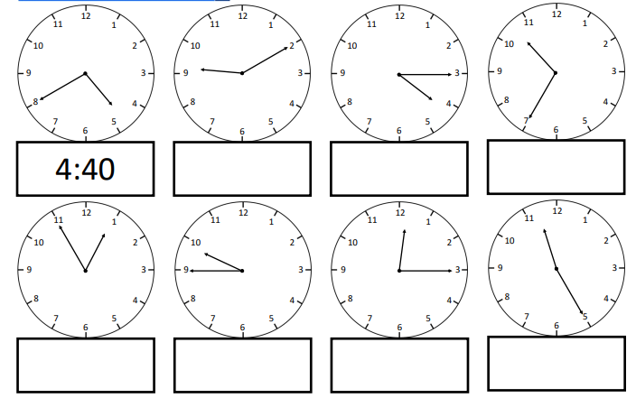Time- to the nearest 5 minutes, including quarter past/ to the hour