Maths Challenge Year 2

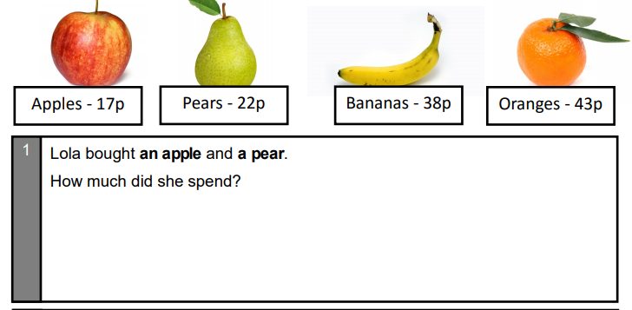Amber Challenge

