,
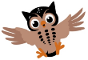
Moss Hey Primary School
Year Two Home Learning
Hi Year 2,
What a wet week! I thought it was going to rain but not that much!!
Thanks again for all your messages, videos and voice notes! You are definitely keeping busy.
Thank you for all your fabulous Rain poems and performances. It was so lovely to see you and your happy faces. Impressive work again Year 2!

I have chosen a Science activity this week for your Feedback task.
Looking forward to seeing what you create.
Take care and hopefully we will see some sunshine soon!!
Mrs Malkin

This week’s feedback task will be:
A Science focus- Food detectives

The theme this week is: Food


Spot the themed activities in the Home Learning grid!

You will find a selection of home learning activities for your child below. Evidence suggests that at primary school level there are two things which make the greatest difference to your attainment linked to home learning:

1. Reading regularly with an adult and discussing what you have read
2. Regular times table practice

English Tasks

English Tasks

English tasks are based around the theme: Food
Complete the three tasks- refer to English activities on the blog for tasks and instructions.

Reading:
Green reading challenge- Non-fiction-Healthy Eating
Amber reading challenge- Non-fiction- Greek salad recipe
Red reading challenge- Non-fiction- Greek salad recipe

Spelling/Grammar/Punctuation/Vocabulary:

Year 2 spelling booklet- Continue to complete the spelling activities.
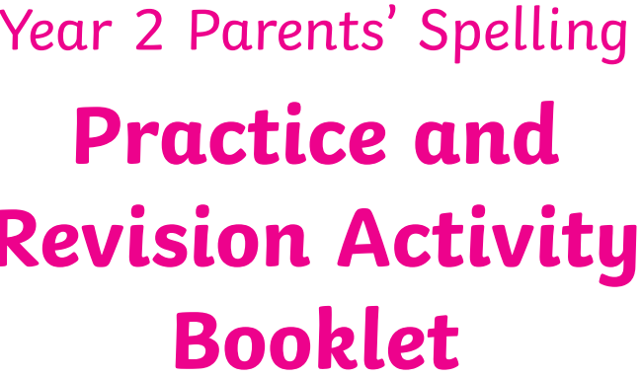

Maths Tasks

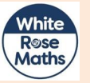

White Rose Maths https://whiterosemaths.com/homelearning/year-2/ The worksheets can now be found attached within the blog. Watch the daily video and complete the worksheet.
(Summer Term –Remember we are a week behind so you will need to scroll down to Week 10: W/C 29th June – Mass, Volume and Capacity)
Following on from last week’s problem solving challenges I have included another challenge for you to have a go at completing. There is RED, AMBER and GREEN challenge for you to choose from. Have fun!
BBC Bitesize - The BBC has put together daily maths lessons for children to access. Explore the maths lessons for Year 2. They link with White Rose Maths and have a daily TV programme too.

Mathletics

Well done to the children who have logged on to Mathletics and had a go at some of the challenges we have set.
Theme Tasks
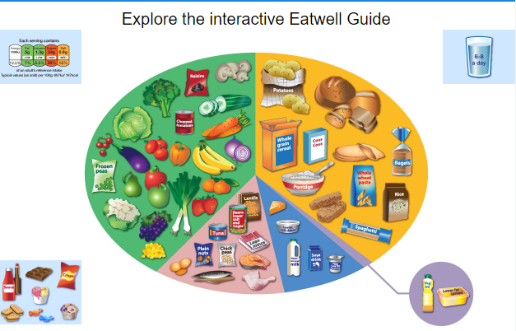
Science
FEEDBACK TASK
Food Detective Project the importance of eating the right amount of different types of food
There are 4 tasks to complete. Refer to the attached file with the tasks and instructions.

RE-
Traditional food: Many cultures have various dishes of food to celebrate their festivals.
Find out about a festival and compare it to a different festival.
What are the similarities? What are the differences? How is the food prepared?
Do you have any traditional food you enjoy with your family?
Create poster or video to share what you have discovered.
Art-
Look at the Powerpoint- All about Giuseppe Arcimboldo.
Can you create portrait in the style of Arcimboldo- use a collage technique or actual food!

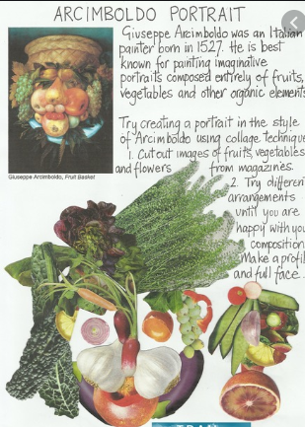
Ongoing Weekly Tasks
Decodable Phonic comics for applying phonic skills-www.phonicsplaycomics.co.uk/index.htlm

Letter and Sound daily lessonhttps://www.youtube.com/channel/UCP_FbjYUP_UtldV2K_-niWw/channels?view_as=public&fbclid=IwAR3oPhtObguFbJJJBem1RroKppgOhCYjkzT2QJHjbSxQ3QwbErApPKaEpz4

BBC Bitesize- They have released some great lessons with teachers that the children can access and follow through independently.
TT Rockstars- Online timestable practise.
Mathletics- You should have your login details from ClassDojo so login and complete some of the work set and play some games.
Oxford Owl – Online ebooks which match your child’s reading book band.
Classroom Secrets – Online activities that your child can access.
White Rose Maths- This is the scheme we follow in school and they continue to update it with activities that can be completed at home.
Spelling/phonics- related to your year group or what you are covering in school.
ICT Games – Interactive Maths and English games.
Once Upon a Picture – A selection of interesting images which can inspire your child to write. It could be a story, a recount, a set of instructions, whatever motivates your child.
Pobble 365 – Short daily writing tasks
Roy the Zebra – Interactive reading games.
Topmarks - A range of interactive activities for all subject areas throughout the curriculum.

