Moss Hey Primary School
Year Five Home Learning
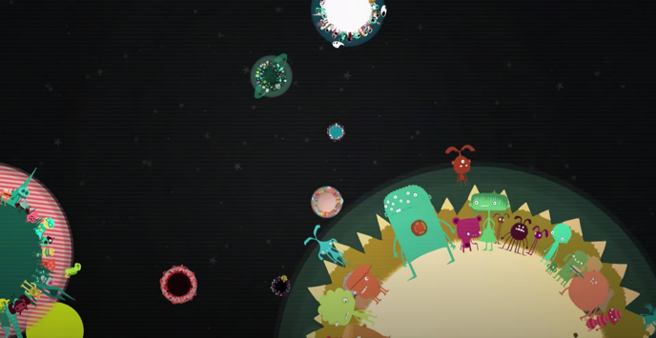
Hello Year 5,

I really enjoyed reading your stories. I’ve given feedback, to those who have submitted, so if you have submitted your story and I’ve not given you any feedback please let me know.

The piece of work I would like you to upload onto Seesaw is Friday’s English advert / flyer. You can create it electronically, or draw it by hand, see below.


English Tasks

Upload Friday’s task onto Seesaw

Monday – up-level your short story from the feedback I have given.

Tuesday – complete the grammar tasks

Wednesday – Watch the video https://www.youtube.com/watch?v=QDLHZjw83BI write a short diary recount of from the point of view of the astronaut – you must include your thoughts and feelings as well as a description of the setting and one of the robots.

Thursday – Watch the video https://www.youtube.com/watch?v=ICm7CWDPXXk write 6 different types of sentences about one of the planets (Not Planet 6).
- Use an expanded noun phrase
- Use a complex sentence
- Use a compound sentence
- Use an embedded clause
- Use a fronted adverbial
- Imagine your target audience are people who know a great deal about planets (they are called: astronomers), write a sentence which includes technical vocabulary (you must understand every word you use) – you must look up in a dictionary 3 words which were unfamiliar to you before today.

Friday – Watch the video https://www.youtube.com/watch?v=ICm7CWDPXXk, but this time just for planet 6 – write a set of rules for the argumentative aliens of the planet – make sure your punctuation is accurate – I would like you to present it as a 1 page advert/flyer to the whole population of the planet. You can do it on the computer or by hand – then upload your 1 page advert / onto Seesaw for me to review.

Note: I have loaded the help sheets (adjectives, Conjunctions etc.) on both the web blog and Seesaw – they are the same sheets – I thought it might make life easier.

Reading Comprehensions

I have loaded a number of different reading comprehensions onto the web blog. Children should complete 1 each day.

Spellings

This week we are looking at adding the prefix ‘over’ to words. I’ve included a word search, a Look Say Cover Write and Check Activity and a word jumble puzzle.

Alternatively – Work on the Oak National Curriculum or BBC Bitesize which are still available online.

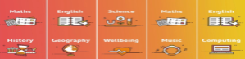



Maths Tasks

This week in maths I have downloaded a series of sheets for Fraction & Decimals – there are about 40 different worksheets (all contained in 1 file), so I believe this is enough for 2 weeks of work – If anyone does need more next week then please ask and I will get some – otherwise, I will assume this is plenty for two weeks.

What Are Percentages
https://www.youtube.com/watch?v=JeVSmq1Nrpw

Convert fractions to decimals
https://www.youtube.com/watch?v=do_IbHId2Os

Converting between fractions, decimals and percentages
https://www.youtube.com/watch?v=-Xt4UDk7Kzw

Mathletics



Well done to the children who have logged on to Mathletics and had a go at some of the challenges we have set. Please try and complete at least one task this week and try out the games. If you haven’t logged on yet, please prioritise this as one of your maths tasks for this week.

PSHE – Needs Parent Support

This week’s theme is: Worry

The following links will take you to a website which we use in class. I would recommend that you do not let the children do this activity without adult supervision.

Click on the link for the teacher guide and when it prompts you to watch the video you can click on the bottom link.

Click on here for the lesson guide:
https://schools.1decision.co.uk/info/presentations/fae-lesson-guide-worry/index.htm

Click here for to watch the video
https://schools.1decision.co.uk/info/videos/fae-scorm-worry/index.html

Click here to watch the relaxation video:
https://schools.1decision.co.uk/info/videos/fae-scorm-butterfly-meadow/index.html

Geography

Complete this activity this week

This week I would like you to compare a region in the UK with a region in North America – It is your choice which regions you choose. Things to think about:

What is our local area like? How would you describe it? How many people live there? What kinds of jobs do people have? What is our culture like compared to theirs.

You will need to review both human and physical aspects of geography – what is the difference between the two?
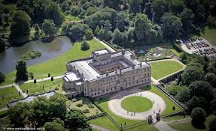


Computing

- Find out about keeping safe online by following the adventures of Kara Winston and the SMART crew: https://www.childnet.com/resources/the-adventures-of-kara-winston-and-the-smart-crew

- There is more information about e safety here: https://www.saferinternet.org.uk/advice-centre/young-people/resources-3-11s

- Can you show what you have found out electronically? You could do a vlog or a podcast!

- Try some coding on https://studio.code.org – you can browse the different learning areas or start on this course: https://studio.code.org/s/coursec-2019

- Each course starts with a video to teach you skills.

Ongoing Weekly Tasks

BBC Bitesize- They have released some great lessons with teachers that the children can access and follow through independently.
TT Rockstars- Online timestable practise.
Mathletics- You should have your login details from ClassDojo so login and complete some of the work set and play some games. I will add more things on here throughout the week.
Oxford Owl – Online ebooks which match your child’s reading book band.
Classroom Secrets – Online activities that your child can access.
White Rose Maths- This is the scheme we follow in school and they continue to update it with activities that can be completed at home.
Spelling/phonics- related to your year group or what you are covering in school.
ICT Games – Interactive Maths and English games.
Once Upon a Picture – A selection of interesting images which can inspire your child to write. It could be a story, a recount, a set of instructions, whatever motivates your child.
Pobble 365 – Short daily writing tasks
Roy the Zebra – Interactive reading games.
Topmarks - A range of interactive activities for all subject areas throughout the curriculum.

