,

Moss Hey Primary School
Year Two Home Learning
Hi Year 2,
We hope you have had a great week despite the weather being rather wet!
I have absolutely loved receiving all your Maths Challenges this week. I am so impressed with how you tackled the tricky problem solving tasks. I have had videos, photos and pictures of all your workings out!
Mrs Messham thinks Year 2 are working so hard and is so proud of you too!
We know it is tricky keeping motivated at home!

SO A BIG WELL DONE AND THANK YOU!

This week’s feedback task will be:
A writing focus- Creating and performing poetry.

The theme this week is: Rain

Spot the themed activities in the Home Learning grid!

You will find a selection of home learning activities for your child below. Evidence suggests that at primary school level there are two things which make the greatest difference to your attainment linked to home learning:

1. Reading regularly with an adult and discussing what you have read
2. Regular times table practice

English Tasks

English Tasks

English tasks are based around the theme: Rain.


FEEDBACK ACTIVITY

Rain
Having been blessed with glorious weather recently, the arrival of the rain can be a welcome stimulus. There is nothing more powerful than real-life experience, especially when it comes to creative writing.
English
- List poetry
- Simile, metaphor, personification, onomatopoeia
- Drawing upon the senses
- Fact and opinion
- Personal memory
Refer to English activiites- Rain for this week’s tasks and instructions.
Looking forward to seeing all your poems this week. Remember to upload to SEESAW.

Reading:
- Water Woman:A Super hero reading comprehension
- There is also a non-fiction comprehension to look at-The water Cycle

Spelling/Grammar/Punctuation/Vocabulary:

Year 2 spelling booklet- Have a go at completing some of these spelling activities.
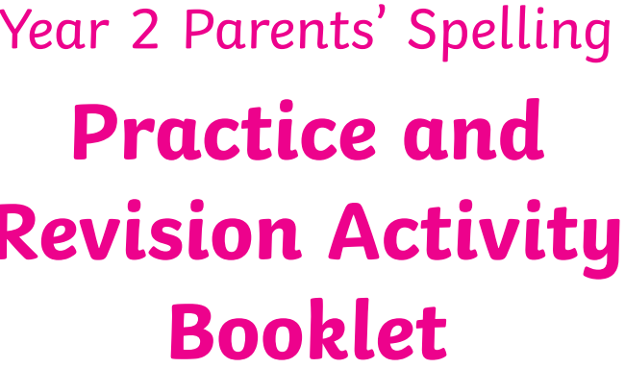

Maths Tasks



White Rose Maths https://whiterosemaths.com/homelearning/year-2/ The worksheets can now be found attached within the blog. Watch the daily video and complete the worksheet.
(Summer Term – Remember we are a week behind so you will need to scroll down to Week 9: W/C 22th June - Length And Mass )
Following on from last week’s problem solving challenges I have included another challenge for you to have a go at completing. There is RED, AMBER and GREEN challenge for you to choose from. Have fun!
BBC Bitesize - The BBC has put together daily maths lessons for children to access. Explore the maths lessons for Year 2. They link with White Rose Maths and have a daily TV programme too.

Mathletics

Well done to the children who have logged on to Mathletics and had a go at some of the challenges we have set.
Theme Tasks
Science
Have a go at creating the rain cloud in a jar experiment.

Have a go at making a rain gauge.
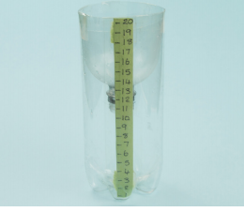
Refer to blog for instructions.

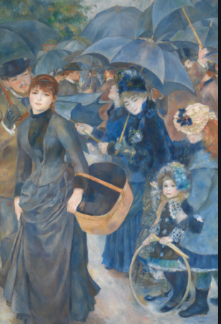
Art-
Have a go at creating a piece of art based on RAIN!
Use Renoir umbrella painting as inspiration.


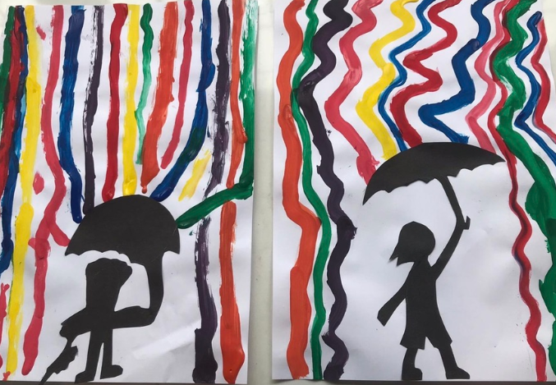
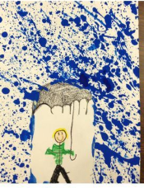
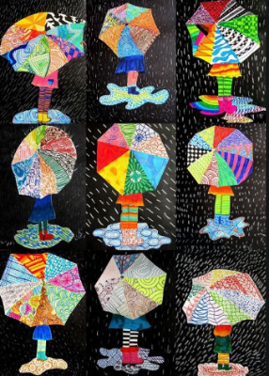
Ongoing Weekly Tasks
Decodable Phonic comics for applying phonic skills-www.phonicsplaycomics.co.uk/index.htlm

Letter and Sound daily lessonhttps://www.youtube.com/channel/UCP_FbjYUP_UtldV2K_-niWw/channels?view_as=public&fbclid=IwAR3oPhtObguFbJJJBem1RroKppgOhCYjkzT2QJHjbSxQ3QwbErApPKaEpz4

BBC Bitesize- They have released some great lessons with teachers that the children can access and follow through independently.
TT Rockstars- Online timestable practise.
Mathletics- You should have your login details from ClassDojo so login and complete some of the work set and play some games.
Oxford Owl – Online ebooks which match your child’s reading book band.
Classroom Secrets – Online activities that your child can access.
White Rose Maths- This is the scheme we follow in school and they continue to update it with activities that can be completed at home.
Spelling/phonics- related to your year group or what you are covering in school.
ICT Games – Interactive Maths and English games.
Once Upon a Picture – A selection of interesting images which can inspire your child to write. It could be a story, a recount, a set of instructions, whatever motivates your child.
Pobble 365 – Short daily writing tasks
Roy the Zebra – Interactive reading games.
Topmarks - A range of interactive activities for all subject areas throughout the curriculum.

