**While we can’t hug**

**Task 1 – List three feelings the animals may have felt when they were told they couldn’t hug.**

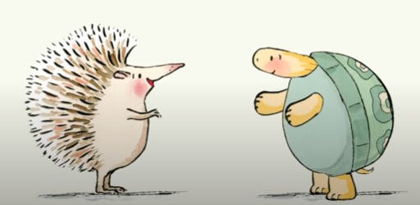

**Task 2 – What are the ways the hedgehog and the tortoise showed each other they were loved?**

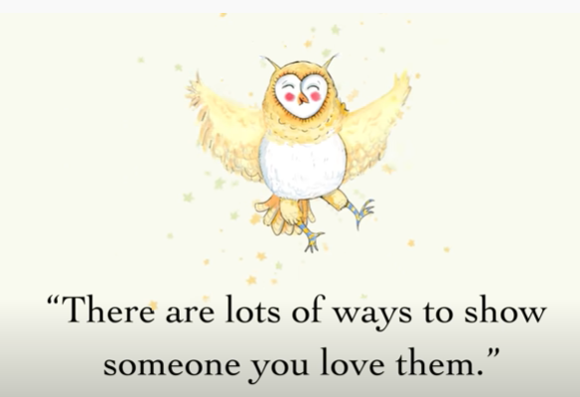

**Task 3 – How are you going to show your friends that you love them?**

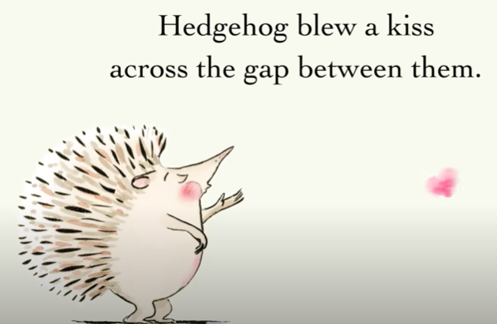

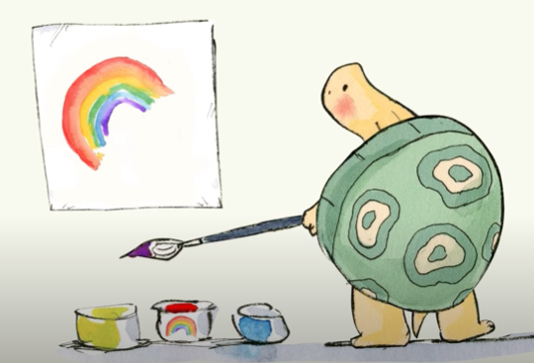**Task 4 – Draw a picture for your best friend.**