Year 2 Comprehension

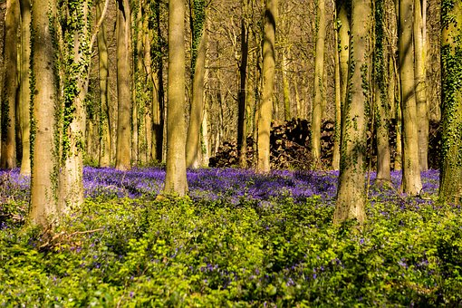Habitats

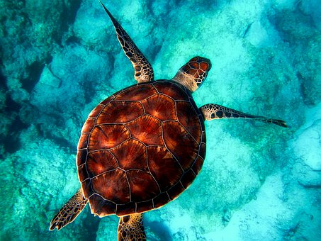

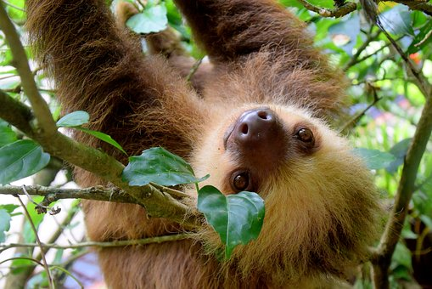

Useful words

ocean

covered

shelter

**Habitats**

**A *habitat* is an animal or plant’s home. It might be a desert, ocean, woodland or seashore.**

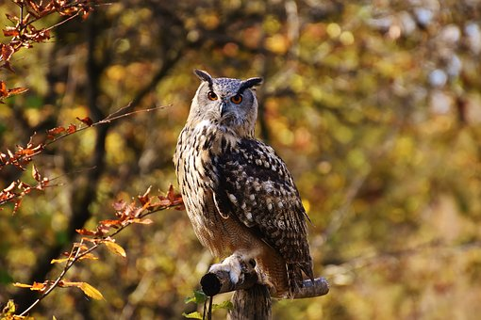

**Lots of different plants and animals live in one habitat.**

**Let’s find out more…**

**Questions**

1. What does ‘habitat’ mean?
2. What sort of habitats are there? **Tick three.**

Ocean Owl

Woodland Desert



**Habitat:** Woodland

**What it’s like:**

* Tall trees, perfect for shelter
* Dead leaves and logs on the floor

**Who lives there:**

Owls, thrushes, oak trees, snails…

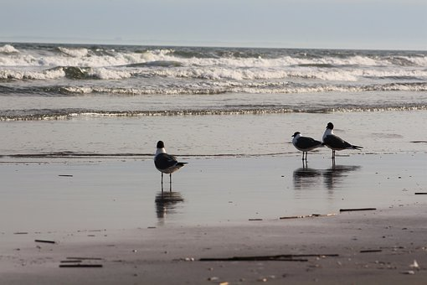

**Habitat:** Seashore

**What it’s like:**

* Rocky, sandy or muddy
* Can be covered by the tide
* Can be very dry

**Who lives there:**

Starfish, crabs, seabirds, fish…

**Questions**

1. What do animals use for shelter in the woodland?
2. **Tick** **3** words describing the seashore.

Tide Rocky

Dry Sandy

1. **Write one** animal found at the seashore.

**Habitat:** Ocean

**What it’s like:**

* Can be warm
* Can be frozen
* Can be deep
* Can be shallow

**Who lives there:**

Cod, sharks, whales, turtles, penguins…





**Habitat:** Tropical Rainforest

**What it’s like:**

* Warm and wet
* The top is very dark

**Who lives there:**

Monkeys, frogs, lizards, sloths, small cats…

**Questions**

1. Which animals live in the ocean? **Tick three.**

Cod Penguins

Monkeys Turtles

1. **Find** and **copy** **one** word meaning ‘damp.’
2. True or false? The rainforest is bright. **Tick.**

True False

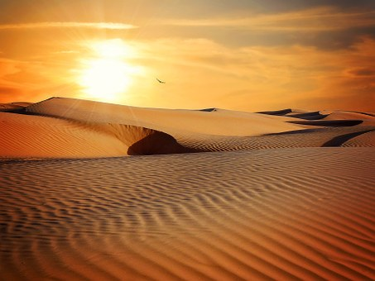

**Habitat:** Desert

**What it’s like:**

* Dry
* Very hot or very cold
* Not much shelter
* Sandy

**Who lives there:**

Palm trees, rattlesnakes, , gerbils, scorpions…



**Habitat:** City

**What it’s like:**

* Noisy and busy
* Lots of rubbish

**Who lives there:**

Squirrels, sparrows, foxes, rats, humans…

**Questions**

1. What sort of tree can you find in the desert?
2. Draw a line between the habitat and the description.

Can be deep or shallow

Desert

Ocean

Home to thrushes and snails

Dry and sandy

Woodland

Answers

1. A habitat is an animal’s or plant’s home
2. Ocean/woodland/desert
3. Trees
4. Rocky/.sandy/dry
5. Starfish/crabs/seabirds/fish
6. Cod/penguins/turtles
7. Wet
8. False
9. Palm
10. Desert – Dry and sandy

Ocean – Can be deep or shallow

Woodland – Home to thrushes and snails