Year 2 Comprehension

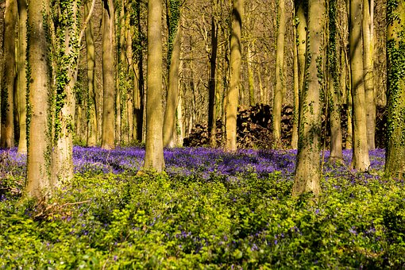Habitats

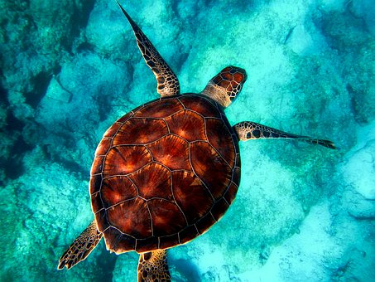

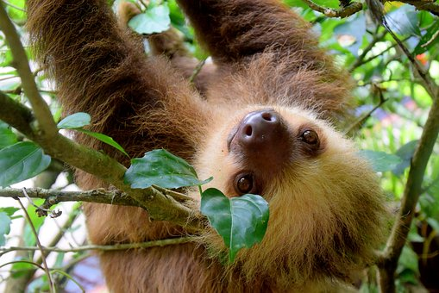

Useful words

ocean

tropical

covered

**Habitats**

**A *habitat* is an animal or plant’s home. It might be a desert, ocean, woodland or seashore among many others. Lots of different plants and animals live in one habitat.**

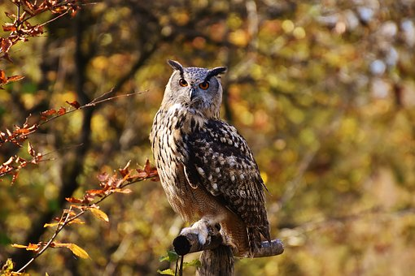

**Every animal or plant is suited to its habitat. For example, an owl can survive in the woodland because there is lots of shelter from the trees. But it wouldn’t find it easy to live in a desert where there aren’t many places to hide.**

**Let’s find out more…**

**Questions**

1. What does ‘habitat’ mean?
2. **Tick one** reason an owl **wouldn’t** like the desert.

It is too deep It is too wet

There is lots of shelter There is nowhere to hide



**Habitat:** Woodland

**What it’s like:**

* Tall trees, perfect to shelter birds
* Dead leaves and logs on the floor

**Who lives there:**

Owls, thrushes, oak trees, snails, badgers…

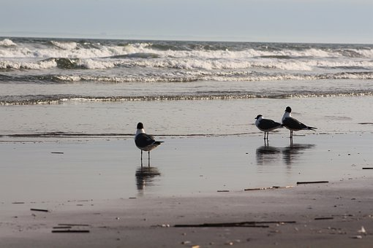

**Habitat:** Seashore

**What it’s like:**

* Rocky, sandy or muddy
* Some of the shore is covered by the tide
* Some of the shore is very dry

**Who lives there:**

Starfish, crabs, seabirds, anemones, fish…

**Questions**

1. What do animals use for shelter in the woodland?
2. Write **3** adjectives describing the seashore.

1. **Find** and **copy one** word meaning ‘waterless.’

**Habitat:** Ocean

**What it’s like:**

* Can be warm and tropical
* Can be frozen
* Can be deep
* Can be shallow

**Who lives there:**

Cod, sharks, whales, turtles, penguins…



**Habitat:** Tropical Rainforest

**What it’s like:**

* Tropical rainforests are warm, wet and have tall trees
* The top is very dark, so animals need a loud call to talk to each other

**Who lives there:**

Monkeys, frogs, lizards, sloths, small cats…



**Questions**

1. Which animals live in the ocean? **Tick three.**

Cod Penguins

Monkeys Turtles

1. **Find** and **copy** **one** word meaning ‘damp.’
2. What is it like at the top of the rainforest?

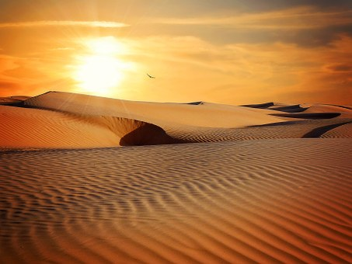

**Habitat:** Desert

**What it’s like:**

* Very dry
* Very hot or very cold
* Not much shelter
* Sandy

**Who lives there:**

Cacti, palm trees, rattlesnakes, , gerbils, scorpions…



**Habitat:** City

**What it’s like:**

* Noisy and busy
* Lots of rubbish

**Who lives there:**

Squirrels, sparrows, foxes, rats, humans…

**Questions**

1. What sort of plants can you find in the desert? **Write two.**
2. Draw a line between the habitat and the description.

Can be deep or shallow

Desert

Ocean

Home to thrushes and snails

Dry and sandy

Woodland

Answers

1. A habitat is an animal’s or plant’s home
2. There is nowhere to hide
3. Trees
4. Rocky/.sandy/muddy/sheltered/exposed
5. Dry
6. Cod/penguins/turtles
7. Wet
8. Dark
9. Cacti/palm trees
10. Desert – Dry and sandy

Ocean – Can be deep or shallow

Woodland – Home to thrushes and snails