Year 2 Comprehension

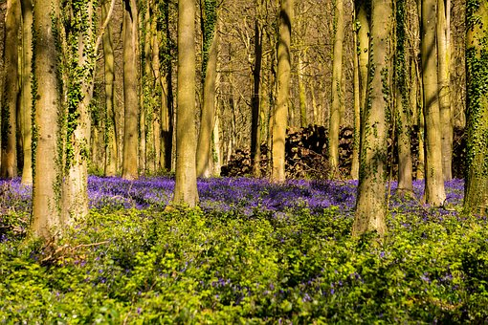Habitats

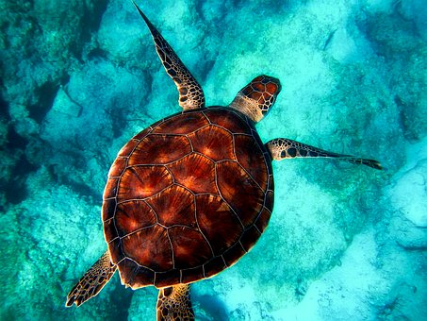

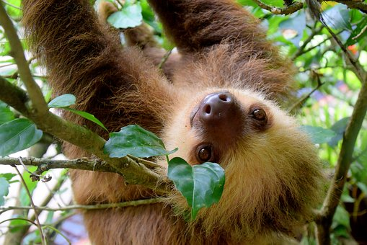

Useful words

exposed

tropical

communicate

**Habitats**

**A *habitat* is an animal or plant’s home. It might be a desert, ocean, woodland or seashore among many others. Lots of different plants and animals live in one habitat.**

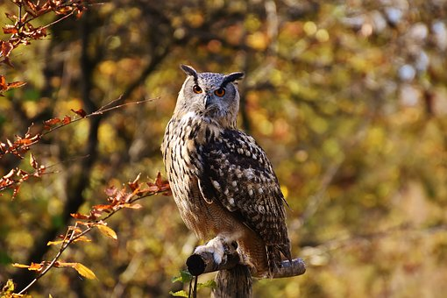

**Every animal or plant is suited to its habitat. For example, an owl can survive in the woodland because there is lots of shelter from the trees and plenty of small rodents to eat. But it wouldn’t find it easy to live in a desert where it would be too hot and there wouldn’t be anywhere to hide.**

**Let’s find out more…**

**Questions**

1. Define the word ‘habitat.’
2. **Tick two** reasons an owl **wouldn’t** like the desert.

It is too hot It is too wet

There is lots of shelter There is nowhere to hide



**Habitat:** Woodland

**What it’s like:**

* Tall trees, perfect to shelter birds
* Dead leaves and logs on the floor to provide food and shelter for mini-beasts

**Who lives there:**

Owls, thrushes, oak trees, caterpillars, snails, badgers…the list goes on and on!

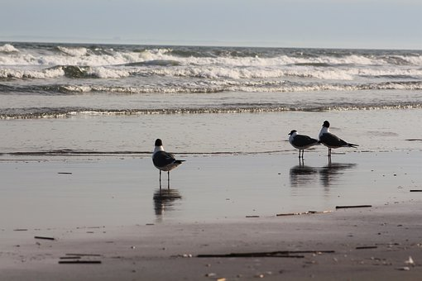

**Habitat:** Seashore

**What it’s like:**

* Rocky, sandy or muddy
* Sometimes sheltered, sometimes exposed
* Some of the shore is covered by the tide
* Some of the shore is very dry

**Who lives there:**

Starfish, crabs, seabirds, anemones, fish…

**Questions**

1. How do animals stay safe in the woodland?
2. Write **3** adjectives describing the seashore.

1. **Find** and **copy one** word meaning ‘waterless.’

**Habitat:** Ocean

**What it’s like:**

* Can be warm and tropical
* Can be frozen
* Can be deep
* Can be shallow
* Perfect for an enormous variety of wildlife to thrive

**Who lives there:**

Cod, sharks, whales, turtles, penguins…



**Habitat:** Tropical Rainforest

**What it’s like:**

* Tropical rainforests are warm, wet and have tall trees
* The top is very dark so animals need a loud call to communicate

**Who lives there:**

Monkeys, frogs, lizards, sloths and small cats love the top of the trees, which is called the canopy



**Questions**

1. What animals live in the ocean? **Tick three.**

Cod Penguins

Monkeys Turtles

1. **Find** and **copy** **one** word meaning ‘damp.’
2. Why do rainforest animals need a loud call?

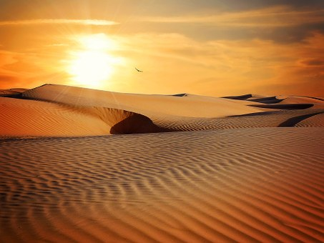

**Habitat:** Desert

**What it’s like:**

* Extremely dry
* Either very hot or very cold
* Not much shelter
* Sandy

**Who lives there:**

Cacti, palm trees, rattlesnakes, llamas, gerbils, scorpions…

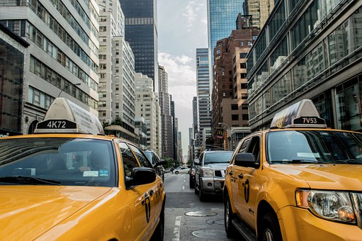

**Habitat:** City

**What it’s like:**

* Noisy and busy
* Lots of rubbish

**Who lives there:**

Squirrels, sparrows, foxes, rats, humans…

(Yes, humans are an animal too! Lots of humans choose to live in the city where there are supermarkets on every corner, lots of transport and the shelter of warm, dry buildings.)

**Questions**

1. Why might humans choose to live in cities? Write **three** reasons.
2. Draw a line between the habitat and the description.

Can be deep or shallow

Desert

Ocean

Home to thrushes and caterpillars

Dry and sandy

Woodland

Answers

1. A habitat is an animal’s or plant’s home
2. It is too hot/there is nowhere to hide
3. There are tall trees for shelter
4. Rocky/.sandy/muddy/sheltered/exposed
5. Dry
6. Cod/penguins/turtles
7. Wet
8. Because it is dark at the top of the trees (in the canopy)
9. There are supermarkets/lots of transport/shelter
10. Desert – Dry and sandy

Ocean – Can be deep or shallow

Woodland – Home to thrushes and caterpillars