Maths Challenge Year 2

FEEDBACK ACTIVITY

Amber Challenge

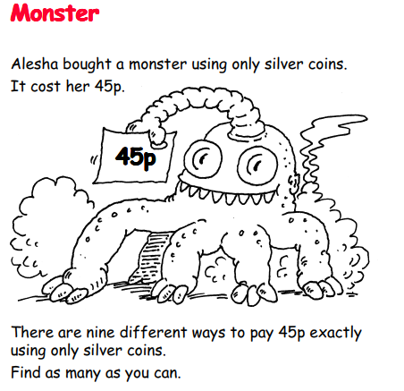

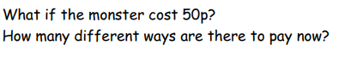

Record your answers and share with me on Seesaw.

Focus:

