Maths Challenge Year 2

FEEDBACK ACTIVITY

Red Challenge

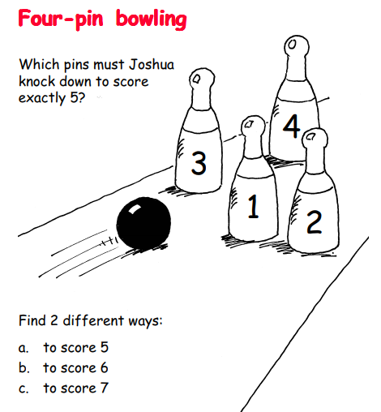

Record you answers and share with me on Seesaw.

Focus:

