Moss Hey Primary School
Year Five Home Learning

Hello Year 5,
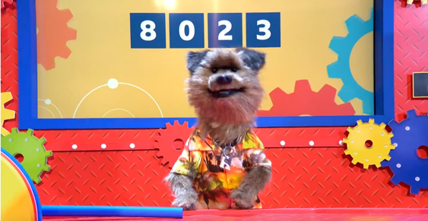
Welcome to week 4 of our Summer 2 term. I hope you are enjoying the science theme of the Earth and Stars, it’s great to see your lovely pictures and descriptions of different creatures.

The piece of work I would like you to upload onto Seesaw is the English story. I would like you to just make a draft version for this week and then after I’ve given some feedback you can complete it next week.

English Tasks
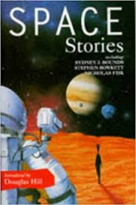
I would like you to write a draft version of a story in 500 words (no more). The story will be about the planet you created last week and some of the creature which inhabit it. Your story might start on Earth with a team going to your planet to explore it or it might be completely set on your planet or a nearby planet – it’s your choice.

It can be in the 3rd or 1st person and set in the past, present or future. I would like you to upload your draft version onto Seesaw so I can give you feedback.
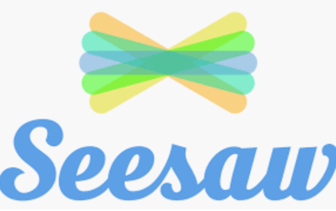

Planning and writing your story

I would like you to watch a video on BBC (it says it’s live but it isn’t now, so please do not contact them – this is an old lesson).

https://www.bbc.co.uk/teach/live-lessons/500-words-2020-live-lesson/zn7jkmn

There are a number of documents on our school web blog you can down load and complete or just write them down in your books and then use the information to write a story. Remember this week I only want your draft version. You can write it down or type it into a computer.

Reading Comprehensions

Similar to last week I’ve chosen some interesting extracts from a variety of different high quality texts.

- Shine
- All Summer in a Day
- The Tempest
- Julius Caesar
- Laws Affecting Women

Spellings

This week we are looking at adding the prefix ‘over’ to words. I’ve included a word search, a Look Say Cover Write and Check Activity and a word jumble puzzle.

Alternatively – Work on the Oak National Curriculum or BBC Bitesize which are still available online.

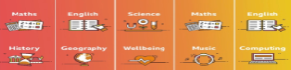



Maths Tasks

This week in maths we are looking at different types of measurement, imperial and metric. In the UK we mainly use metric measurement but for somethings we use imperial, such as miles for distance or feet and inches to measure people’s height.

Math Antics Video on YouTube

This was the video you watched last week, if you need a recap then click on the link to watch it again. This will give you a good overview of the difference between metric measurement and imperial measurement and the different units we use.

https://www.youtube.com/watch?v=cKbmvLv-FRo
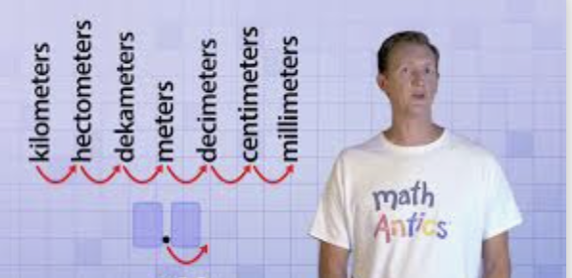
Click on the link to Target maths – this week I have included all the sheets and answers into 1 file to make it easier to download.

I’ve also included the classroom secrets PowerPoint slides to go with the fluency an problem solving questions – please do watch the Math Antics video (link above) before you use these slides.

Alternatively, if you prefer to use BBC Bitesize or Oak National Academy for maths, the links can be found below:

- https://www.bbc.co.uk/bitesize/tags/zhgppg8/year-5-and-p6-lessons
- https://www.thenational.academy/online-classroom/year-5/maths - subjects


Mathletics

Well done to the children who have logged on to Mathletics and had a go at some of the challenges we have set. Please try and complete at least one task this week and try out the games. If you haven’t logged on yet, please prioritise this as one of your maths tasks for this week.
Science – Seesaw Task
The Earth and Stars

This week I would like you to complete the design of your own planet and the introduction – this will help you with your English story

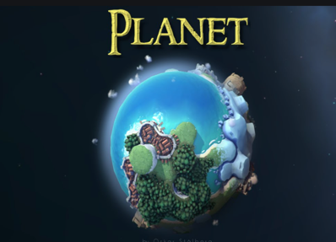
Draw a picture of it and give me as much information about the planet as you can this of – for example, which galaxy / star system is it in?
What moons does it have?
What other planets / moons are nearby? –
What types of biomes exist on the planet?
What life exists in these different biomes?
Are there civilizations?

What types of geographical features exist? Think about you geography work, with physical and human features.
How is life sustained – breath oxygen or hydrogen etc…

Geography

This week I would like you to compare a region in the UK with a region in North America – It is your choice which regions you choose. Things to think about:

What is our local area like? How would you describe it? How many people live there? What kinds of jobs do people have? What is our culture like compared to theirs.

You will need to review both human and physical aspects of geography – what is the difference between the two?
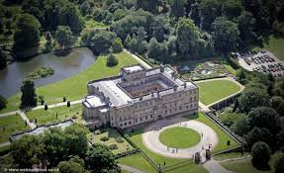
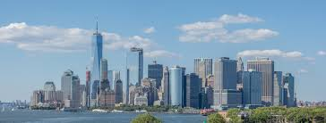

Computing

- Find out about keeping safe online by following the adventures of Kara Winston and the SMART crew: https://www.childnet.com/resources/the-adventures-of-kara-winston-and-the-smart-crew

- There is more information about e safety here: https://www.saferinternet.org.uk/advice-centre/young-people/resources-3-11s

- Can you show what you have found out electronically? You could do a vlog or a podcast!

- Try some coding on https://studio.code.org – you can browse the different learning areas or start on this course: https://studio.code.org/s/coursec-2019

- Each course starts with a video to teach you skills.

Ongoing Weekly Tasks

BBC Bitesize- They have released some great lessons with teachers that the children can access and follow through independently.
TT Rockstars- Online timestable practise.
Mathletics- You should have your login details from ClassDojo so login and complete some of the work set and play some games. I will add more things on here throughout the week.
Oxford Owl – Online ebooks which match your child’s reading book band.
Classroom Secrets – Online activities that your child can access.
White Rose Maths- This is the scheme we follow in school and they continue to update it with activities that can be completed at home.
Spelling/phonics- related to your year group or what you are covering in school.
ICT Games – Interactive Maths and English games.
Once Upon a Picture – A selection of interesting images which can inspire your child to write. It could be a story, a recount, a set of instructions, whatever motivates your child.
Pobble 365 – Short daily writing tasks
Roy the Zebra – Interactive reading games.
Topmarks - A range of interactive activities for all subject areas throughout the curriculum.

