,
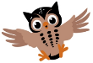
Moss Hey Primary School
Year Two Home Learning

We hope you had a good week last week and are all ready and enthused for another week of home-learning!
This week we are using ‘Seesaw’, our new interactive platform.

Each week, we will provide feedback on one piece of work on ‘Seesaw’ so please upload a photo/ video of this specific task.

Please continue to send photos and work you have done as well to Seesaw to share with me.

This week’s feedback task will be:
A reading task: Animal Character Portrait.

We will look forward to seeing all your hard work!
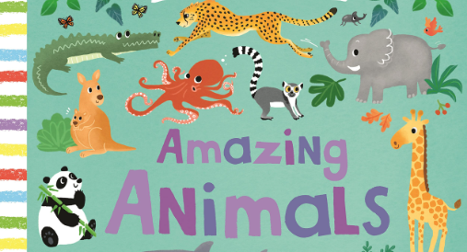
.
The theme this week is: Amazing Animals
Spot the themed activities in the Home Learning grid!

You will find a selection of home learning activities for your child below. Evidence suggests that at primary school level there are two things which make the greatest difference to your attainment linked to home learning:

1. Reading regularly with an adult and discussing what you have read
2. Regular times table practice

English Tasks

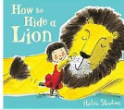
English Tasks

English tasks this week are based around this book:

It is a lovely story about friendship and bravery.
Iris doesn’t care what anyone thinks about lions, not even her mum and dad. They do not want Iris’s friend the lion in their house so Iris needs to find a suitable hiding place. Behind the shower curtains, under the covers and even up trees are places a lion can hide. However, when Iris’ mum finds him the lion has to find himself a hiding place. When the lion witnesses a robbery, it is his chance to show everyone that he is a kind and brave lion.
- Watch the YouTube video- https://www.youtube.com/watch?v=REiuXArnqfk
- I have included a pdf document of the story with illustrations and text. Refer to file on the blog
- English activities for the week- refer to the blog for explanations and instructions. Hope you enjoy the activities!

Reading:
- There are 2 reading comprehensions to choose from this week. Choose from Stage 1, 2 and 3. Stage 3 is quite tricky. Enjoy learning about animals.
- Animal Character Portrait: Choose a book from home which has an animal as the main character- refer to blog for activity- FEEDBACK activity

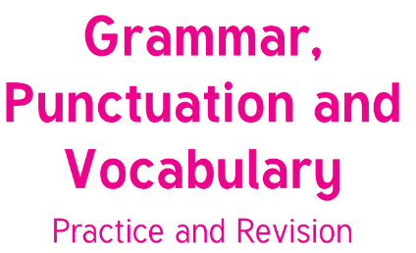
Grammar/Punctuation/Vocabulary:
Continue with this Year 2 Booklet from
last week.

Maths Tasks

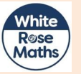

White Rose Maths https://whiterosemaths.com/homelearning/year-2/ The worksheets can now be found attached within the blog. Watch the daily video and complete the worksheet.
(Summer Term – 8st June- Fractions)

Zero to Hero – Addition and subtraction game to practise mental maths skill- see attached file with instructions and game.
BBC Bitesize - The BBC has put together daily maths lessons for children to access. Explore the maths lessons for Year 2. They link with White Rose Maths and have a daily TV programme too.


Mathletics

Well done to the children who have logged on to Mathletics and had a go at some of the challenges we have set. If you haven’t logged on yet, please prioritise this as one of your maths tasks for this week.

Theme Tasks

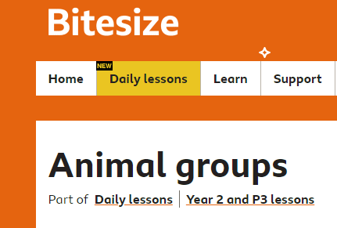
Science-
- https://www.bbc.co.uk/bitesize/articles/z4svgwx

There are lots and lots of different animals all over the world.
Each animal has been classified by scientists so it belongs to a group.
Discover some facts about each group by watching the clips from Bitesize.
There are also activities to complete.
- Choose an animal and find out all about it. Create your own factsheet, an example factsheet is below. Make sure you add fascinating facts.
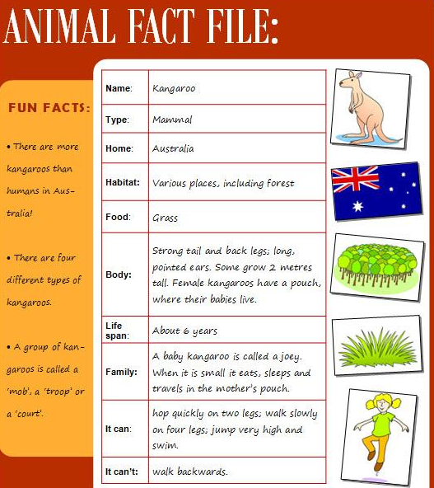

Art- Animal camouflage art
Choose a favourite animal and paint, draw, colour in using what art media you like. Then create a camouflage background. If you have pastels complete you background using the pastels.
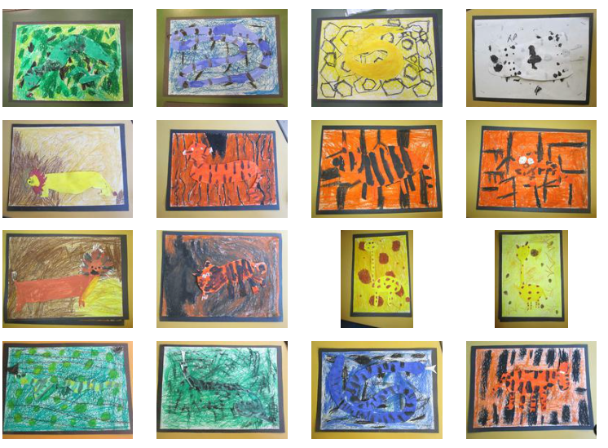

Wellbeing-
At school we take Brain Breaks to re- focus and re- energise when we are working hard in the classroom. Try these 60 second Brain break challenges at home when you are doing your work. There is a challenge record sheet to track what you do! .

Ongoing Weekly Tasks
Decodable Phonic comics for applying phonic skills-www.phonicsplaycomics.co.uk/index.htlm

Letter and Sound daily lessonhttps://www.youtube.com/channel/UCP_FbjYUP_UtldV2K_-niWw/channels?view_as=public&fbclid=IwAR3oPhtObguFbJJJBem1RroKppgOhCYjkzT2QJHjbSxQ3QwbErApPKaEpz4

BBC Bitesize- They have released some great lessons with teachers that the children can access and follow through independently.
TT Rockstars- Online timestable practise.
Mathletics- You should have your login details from ClassDojo so login and complete some of the work set and play some games.
Oxford Owl – Online ebooks which match your child’s reading book band.
Classroom Secrets – Online activities that your child can access.
White Rose Maths- This is the scheme we follow in school and they continue to update it with activities that can be completed at home.
Spelling/phonics- related to your year group or what you are covering in school.
ICT Games – Interactive Maths and English games.
Once Upon a Picture – A selection of interesting images which can inspire your child to write. It could be a story, a recount, a set of instructions, whatever motivates your child.
Pobble 365 – Short daily writing tasks
Roy the Zebra – Interactive reading games.
Topmarks - A range of interactive activities for all subject areas throughout the curriculum.

