Zero Hero is a fun game to play to practice mental math skills, addition and subtraction. It can be played as a single-player game or a multiplayer one.

Things you will need:

* One side 6 dice.
* Print out of the game board. (pdf provided)
* place markers, one for each player
* Paper and pencils to note down some numbers.

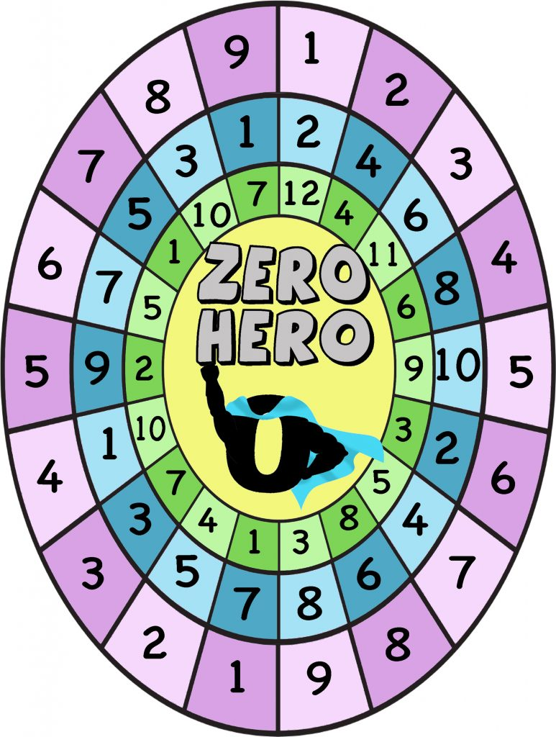

The goal is to be the first one to reach to the middle of the maze to the Zero Hero. There are three levels to pass.

The players take turns rolling the dice.

They start from the outer circle/oval. They roll the dice and start from that number (numbers repeat ) and they can move in any direction around the oval. Every time they roll they can add or subtract each number they land on and try to get to zero. When they get zero they can move to the next inner oval.

Example

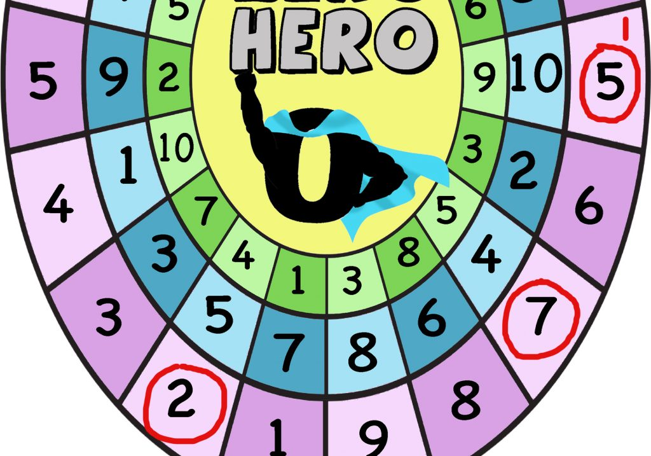

You roll 5 at your first turn and you start from number 5 (choose any of the 5 in the purple oval). At your next turn you roll a 2 so you decide to move two spaces down/right and you get to 7. You can add 5+7=12 or you can subtract 7-5=2 (your goal is to get zero). Let’s say you decide to subtract and now you have 2 (write down your last number each time). At your next turn, you get lucky and roll 4 so you can move to number 2. 2-2=0 Now you can move to the next inner blue oval. You may choose to add your numbers and subtract a greater number at a next turn.

The game offers good practice of addition and subtraction and helps players improve their mental math skills.

Have Fun!