Moss Hey Primary School
Year Five Home Learning

Hello Year 5,
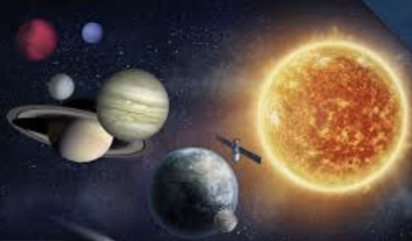
Welcome to week 3 of our Summer 2 term. I hope you are enjoying the science theme of the Earth and Stars, it is a topic which has always excited me.

The piece of work I would like you to upload onto Seesaw is the science work on creating your own planet. I have given more detail below under science as to the success criteria I’m looking for – I hope you enjoy it!

English Tasks

Writing

This pack is brilliant and contains reading, comprehension, SPaG, poetry, and a final performance for all you budding thespians.

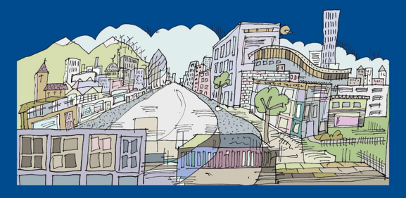
I’ve chosen a Year 6 creative writing task this week; the title is called ‘The City of Silence’ by James Walker. As the children work their way through the activities they will encounter word games; sorting their ideas into categories; look at abstract nouns; create a poem about space and perform one of your pieces of work – I would love to hear you / see you perform your work!! You could always upload it to Seesaw.



Reading Comprehensions

This week I’ve changed the style of reading comprehensions, just to give a bit more variety. As before you will find the reading text, questions and answers (all in different files – I couldn’t do it any other way). These are texts I tended to use in September when I was teaching Year 6, so we should find these as good introductions ready for next year – some may find them challenging as they are quite old these days with different language than we may be used to with more modern texts, but it gives you a good indication as to the level I feel we are at. Look back at the last SATs papers we did for reading – we all nailed it! However, we mustn’t sit back.

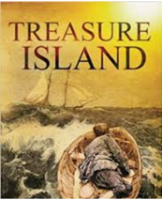
- The Railway Children – E. Nesbit
- Treasure Island – R.L. Stevenson
- Just William – Richmal Crompton
- Why the Whales Came – Michael Morpurgo
- The Log cabin is a picture stimulus with vocabulary, spelling and grammar questions

Spellings

This week we are looking at adding the prefix ‘over’ to words. I’ve included a word search, a Look Say Cover Write and Check Activity and a word jumble puzzle.

Alternatively – Work on the Oak National Curriculum or BBC Bitesize which are still available online.

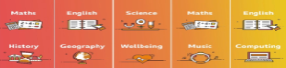



Maths Tasks

This week in maths we are looking at measurement. There are two different systems of measurement you will come across; imperial and metric. In the UK we mainly use metric measurement but for somethings we use imperial, such as miles for distance or feet and inches to measure people’s height.

Math Antics Video on YouTube

Watch the following video on YouTube before you tackle any maths questions this week. This will give you a good overview of the difference between metric measurement and imperial measurement and the different units we use.

https://www.youtube.com/watch?v=cKbmvLv-FRo
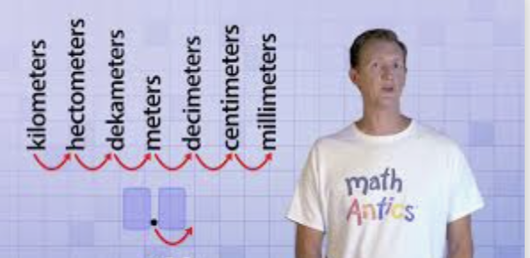
Click on the link to Target maths – this week I have included all the sheets and answers into 1 file to make it easier to download.

I’ve also included the classroom secrets PowerPoint slides to go with the fluency an problem solving questions – please do watch the Math Antics video (link above) before you use these slides.

Alternatively, if you prefer to use BBC Bitesize or Oak National Academy for maths, the links can be found below:

- https://www.bbc.co.uk/bitesize/tags/zhgppg8/year-5-and-p6-lessons
- https://www.thenational.academy/online-classroom/year-5/maths - subjects


Mathletics

Well done to the children who have logged on to Mathletics and had a go at some of the challenges we have set. Please try and complete at least one task this week and try out the games. If you haven’t logged on yet, please prioritise this as one of your maths tasks for this week.
Times Tables SHOUT OUTS!
Huge shout out to the following children who are doing brilliantly on TTRS and are gaining lots of points: Grace R, Joseph, Holly, Reuben, Ella, Erin, Ben, Tom, Andras and Jacob– who have all received over 50,000 tokens!
Extra special shout out to: Scarlet who has so far amassed a massive 385,140 points , and sits well and truly at the top of the school leader board, and to Oscar who continuously keeps breaking his personal best each week.

Science – Seesaw Task

The Earth and Stars

This week I would like you to design your own planet and upload your work so I can provide some feedback on it.

You can use your codes to access Seesaw and photograph your learning for me to look at and mark.

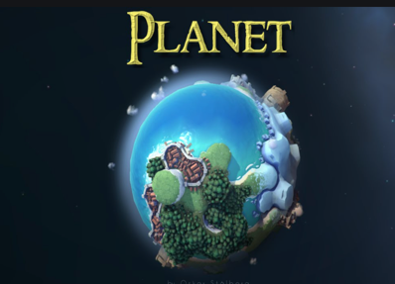
Draw a picture of it and give me as much information about the planet as you can this of – for example, which galaxy / star system is it in?
What moons does it have?
What other planets / moons are nearby? –
What types of biomes exist on the planet?
What life exists in these different biomes?
Are there civilizations?

What types of geographical features exist? Think about you geography work, with physical and human features.
How is life sustained – breath oxygen or hydrogen etc…

Geography

This week I would like you to explore the different time zones of North America and compare them to other time zones around the world. I’ve attached a PowerPoint to help explain.

You will investigate why it’s necessary to have different times across the world – this links into the work you did last week in science looking at how the Earth rotates around the sun – can you remember which model this is and which scientists came up with the theory? Send me your answers on Seesaw!

Computing

- Find out about keeping safe online by following the adventures of Kara Winston and the SMART crew: https://www.childnet.com/resources/the-adventures-of-kara-winston-and-the-smart-crew

- There is more information about e safety here: https://www.saferinternet.org.uk/advice-centre/young-people/resources-3-11s

- Can you show what you have found out electronically? You could do a vlog or a podcast!

- Try some coding on https://studio.code.org – you can browse the different learning areas or start on this course: https://studio.code.org/s/coursec-2019

- Each course starts with a video to teach you skills.

Ongoing Weekly Tasks

BBC Bitesize- They have released some great lessons with teachers that the children can access and follow through independently.
TT Rockstars- Online timestable practise.
Mathletics- You should have your login details from ClassDojo so login and complete some of the work set and play some games. I will add more things on here throughout the week.
Oxford Owl – Online ebooks which match your child’s reading book band.
Classroom Secrets – Online activities that your child can access.
White Rose Maths- This is the scheme we follow in school and they continue to update it with activities that can be completed at home.
Spelling/phonics- related to your year group or what you are covering in school.
ICT Games – Interactive Maths and English games.
Once Upon a Picture – A selection of interesting images which can inspire your child to write. It could be a story, a recount, a set of instructions, whatever motivates your child.
Pobble 365 – Short daily writing tasks
Roy the Zebra – Interactive reading games.
Topmarks - A range of interactive activities for all subject areas throughout the curriculum.

