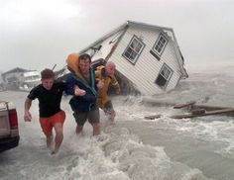

**What do you think happened before this picture was taken?**

**What is happening in this picture?**

**What will happen after this picture?**

**Year 4 Inference**

Look at this picture and answer the following questions. Look carefully at the details within the picture and think about the feelings of the people in it.