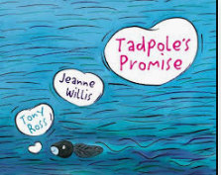

The Tadpole’s promise

By Jeanne Willis

Where the willow tree meets the water, a tadpole met a caterpillar.

They gazed into each other's tiny eyes...and fell in love. He is her “ shiny black pearl" , and she is his " beautiful rainbow" . “I love everything about you,” said the caterpillar. “ Promise you’ll never change.” And foolishly the tadpole promised................... .

But we all know that tadpoles don't stay the same, and neither do caterpillars. When they next meet, he has sprouted two legs. She forgives him, but after he breaks his promise twice more and now looks more like a frog than her "shiny black pearl," the lovelorn larva ends the affair and cries herself to sleep (sequestered in a cocoon).

Meanwhile, the melancholy frog sulks around the pond, making heart-shaped air bubbles that rise to the surface and burst. When the caterpillar awakens, now a butterfly, she decides to forgive her beloved and flies above the water to find him.

She is not even able to complete the sentence, "Have you seen my shiny black ?” when, without a thought, the frog swallows her whole, and then returns to wondering about whatever happened to his "beautiful rainbow."