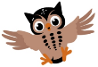
Moss Hey Primary School
Year Two Home Learning
Hello Year 2,
We can’t believe another week has flown by.
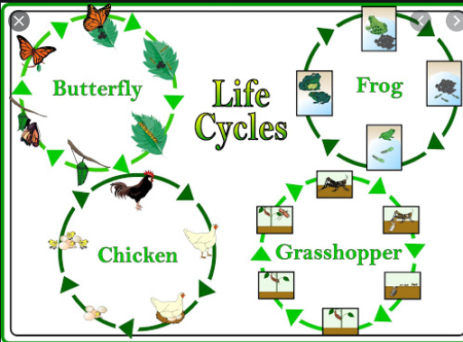

The theme this week is: Life Cycles

Spot the themed activities in the Home Learning grid!

You will find a selection of home learning activities for your child below.
Evidence suggests that at primary school level there are two things which make the greatest difference to your attainment linked to home learning:
1. Reading regularly with an adult and discussing what you have read
2. Regular times table practice

English Tasks

English tasks this week are based around this book:

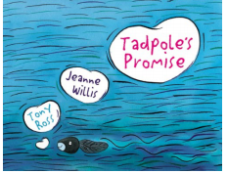

- Watch the you tube video- Tadpoles Promise https://www.youtube.com/watch?v=eKMl-a3-uNY
- I have written out the story for you so you can read the story as well.
- A range of English activities based around the story- refer to attached file on the blog.

Reading:
- Life cycle comprehensions
- The Cautious Caterpillar Story Power point.
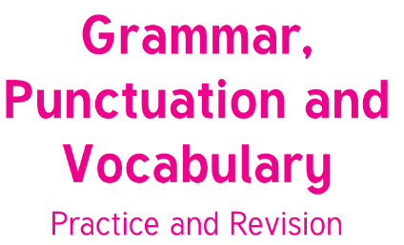
Grammar/Punctuation/Vocabulary:
Have a go at some of the activities in
this Year 2 Booklet.

Maths Tasks



Mathletics- Remember to logon and have a go at the activities. More activities have been added.

White Rose Maths https://whiterosemaths.com/homelearning/year-2/ The worksheets can now be found attached within the blog. Watch the daily video and complete the worksheet.
(Summer Term – 1st June- 10 times tables, make equal groups)
Arrays Maze activity- Refer to blog for the game and instructions- Have fun!
BBC Bitesize - The BBC has put together daily maths lessons for children to access. Explore the maths lessons for Year 2. They link with White Rose Maths and have a daily TV programme too.
Problem of the Day – Please use this link to solve the problem of the day. https://whiterosemaths.com/resources/classroom-resources/problems/

Theme Tasks
Science- research the lifecycles of plants or animals. Use any books you have access to and also the internet. Can you find out about creatures that change in appearance when they become adult? You could also find out about different types of butterflies and frogs.
Art-
Create a life cycle as a work of art.
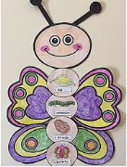
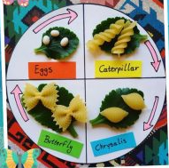
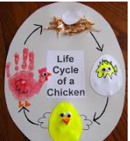

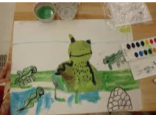

How to draw a frog
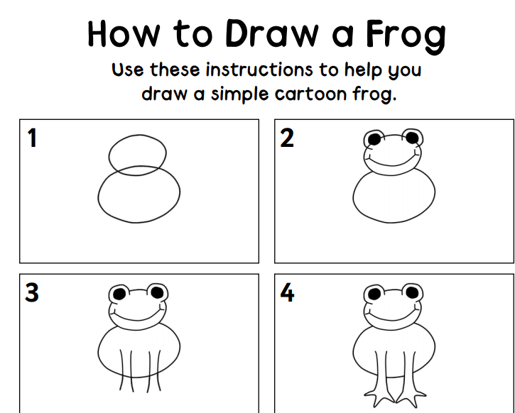 Refer to file in blog.
Wellbeing-
Watch the video of The Hug-https://www.youtube.com/watch?v=12nAI_mLDOg
Stories and hugs, two of my favourite things!
Have a go at creating a Hedgehug and drop it round it to someone who might need one or your favourite people. You can make your own Hedgehog (paper, clay, playdogh, collage) and design a box or something else completely for your Hedgehug to sit in!
This was my Hedgehug.
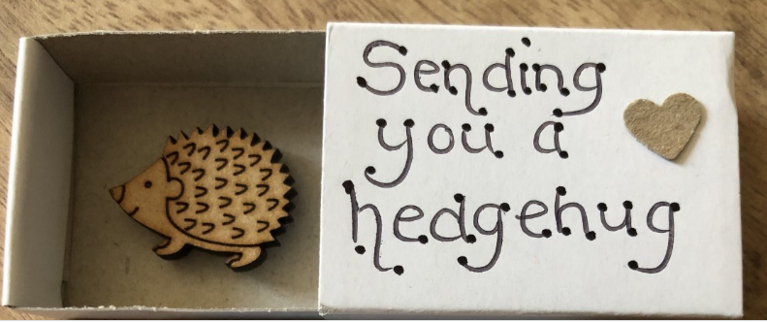
Ongoing Weekly Tasks
Decodable Phonic comics for applying phonic skills-www.phonicsplaycomics.co.uk/index.htlm

Letter and Sound daily lessonhttps://www.youtube.com/channel/UCP_FbjYUP_UtldV2K_-niWw/channels?view_as=public&fbclid=IwAR3oPhtObguFbJJJBem1RroKppgOhCYjkzT2QJHjbSxQ3QwbErApPKaEpz4

BBC Bitesize- They have released some great lessons with teachers that the children can access and follow through independently.
TT Rockstars- Online timestable practise.
Mathletics- You should have your login details from ClassDojo so login and complete some of the work set and play some games.
Oxford Owl – Online ebooks which match your child’s reading book band.
Classroom Secrets – Online activities that your child can access.
White Rose Maths- This is the scheme we follow in school and they continue to update it with activities that can be completed at home.
Spelling/phonics- related to your year group or what you are covering in school.
ICT Games – Interactive Maths and English games.
Once Upon a Picture – A selection of interesting images which can inspire your child to write. It could be a story, a recount, a set of instructions, whatever motivates your child.
Roy the Zebra – Interactive reading games.
Topmarks - A range of interactive activities for all subject areas throughout the curriculum.

