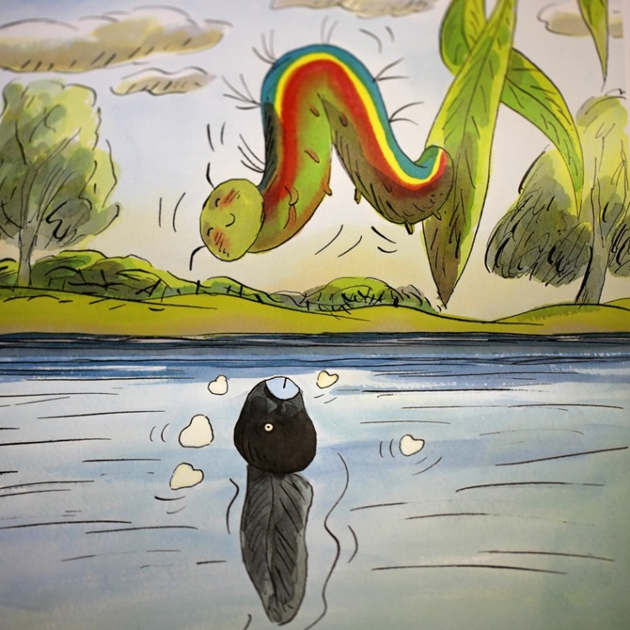

[](http://www.google.co.uk/imgres?q=tadpole's+promise&sa=X&hl=en&biw=1304&bih=712&tbm=isch&tbnid=_cRT3dlqCyx9XM:&imgrefurl=http://class1b-pregny.blogspot.com/2012/07/tadpoles-promise.html&docid=AKgUP8Z19OgnCM&imgurl=http://lh3.ggpht.com/-SkoctfIILac/T_HqScCY-UI/AAAAAAAAIV0/bLfcSkm4ZeU/IMG_9900_thumb.jpg?imgmax=800&w=244&h=244&ei=-sl7Ubq_IIqd0wXpzIDADg&zoom=1&ved=1t:3588,r:19,s:0,i:140&iact=rc&dur=2387&page=1&tbnh=183&tbnw=173&start=0&ndsp=20&tx=94&ty=80)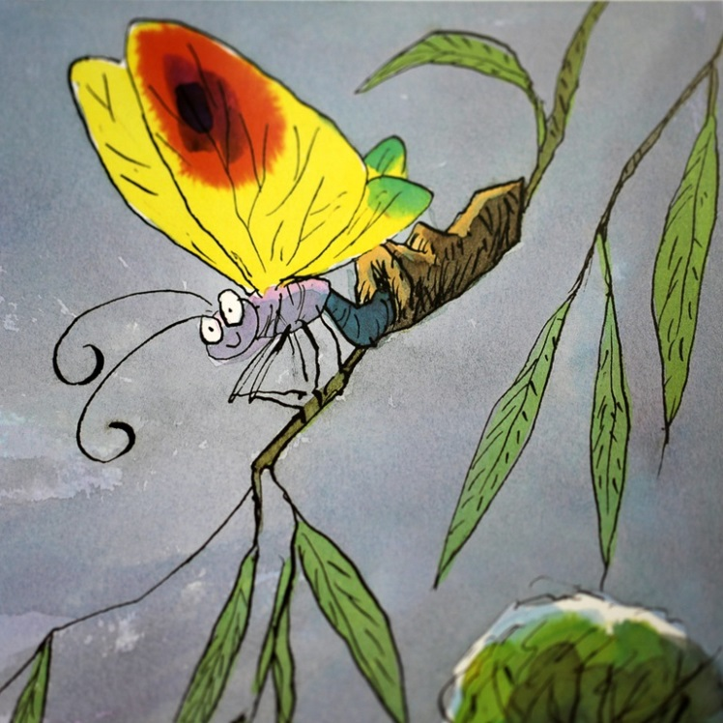

[](http://lh4.ggpht.com/-a80SPM6aMX0/T_HpeO36vSI/AAAAAAAAIS8/sourSMK6aKk/s1600-h/IMG_98943.jpg)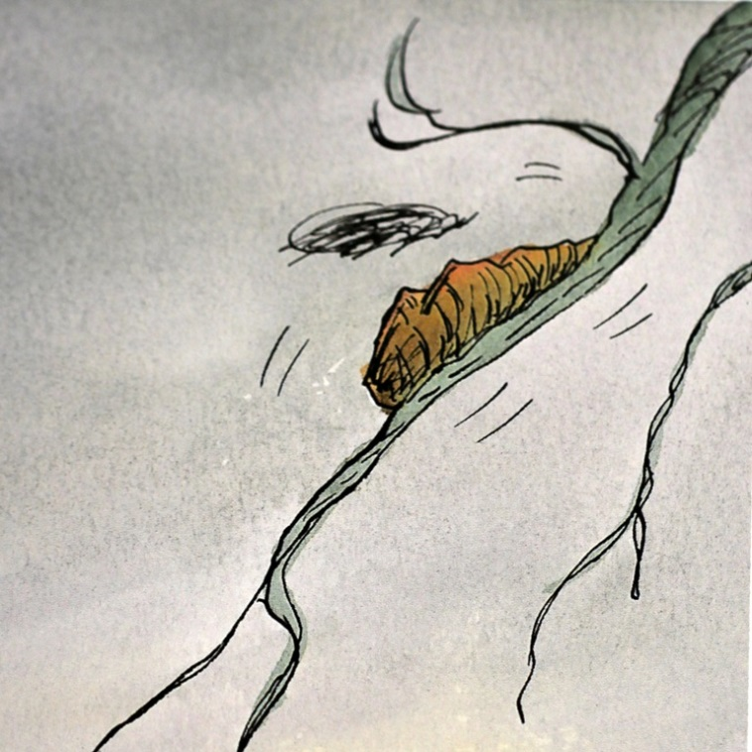

[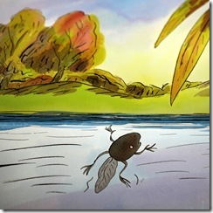](http://lh6.ggpht.com/-P4a9p40yYbI/T_HpaLWoADI/AAAAAAAAISs/hj59ouEh5qY/s1600-h/IMG_98933.jpg)[](http://lh5.ggpht.com/-JLbJQObqPeM/T_Hpk4osSaI/AAAAAAAAITc/n44fLzjt4cE/s1600-h/IMG_98963.jpg)

[](http://lh5.ggpht.com/-MZCOcdj4oFo/T_HqHw4IzzI/AAAAAAAAIVM/QLkhAchPAtM/s1600-h/IMG_98993.jpg)