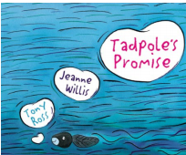**Tadpoles Promise**

**Year 2**

|  |  |
| --- | --- |
| **Discussion questions:** |  |
| **Key Vocabulary** |  |
| **Sequence the story** | **Use the pictures to correctly sequence the story and add captions in full sentences under each picture.** |
| **Speech Bubble** | **Add your own ideas to complete the speech bubble.** |
| **Review- use the special tadpole paper** | **Write a review of this book.**  **Did you like this book? Why?**  **Did you like the ending? Explain**  **Would you recommend this book and to who/why?** |