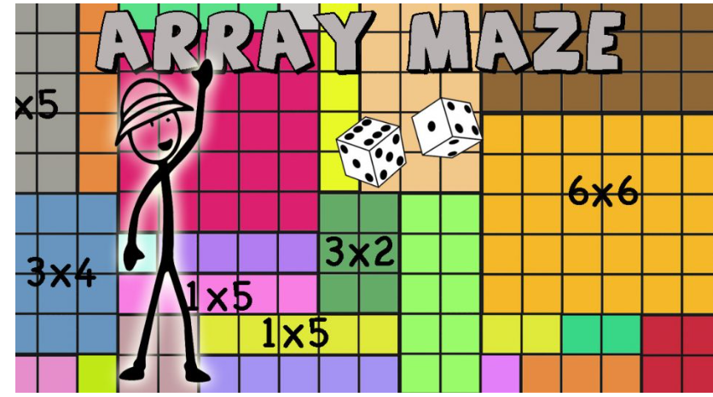

Arrays are a great way to model multiplication. They present multiplication as repeated addition and help understand the properties of multiplication.

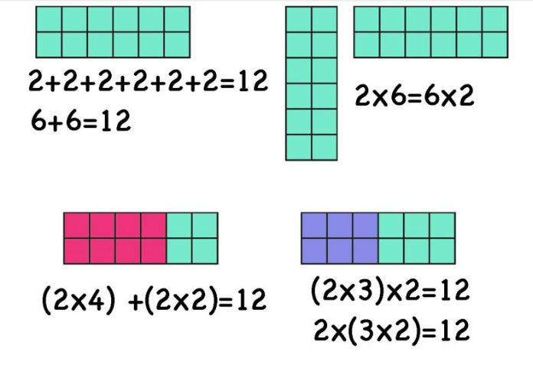

Arrays are a perfect way to first introduce multiplication and start practicing the multiplication facts. This game aims to help practice multiplication by finding the correct array after multiplying two numbers. While playing children gain visual understanding of the multiplication facts and the multiplication properties.

Material:

* Two face 6 dice
* A place marker for each player

Goal: Be the first player to go through and exit the Array Maze.

**How to play**

The players take turns rolling the two dice. They look for the array that models their two numbers multiplied. They need to get an array from the first (top) line to start. Once they are in the maze every turn they must move to any of the arrays that touch the array they are in, (on any side) to make their way to the last (bottom) line to exit the maze. If their rolled numbers match the neighboring arrays they can choose one and move, otherwise, they wait for their next turn.

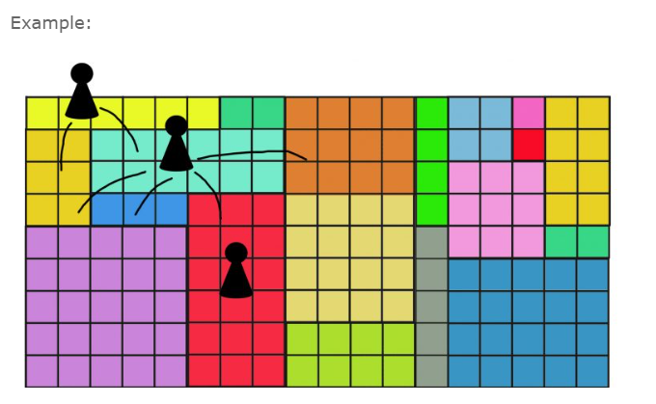Then they can use that path to write down the arrays and solve them.

The first player to reach the bottom line (land on an array on the last line) wins.