
Moss Hey Primary School
Year Four Home Learning

You will find a selection of home learning activities for your child below.
Evidence suggests that at primary school level there are two things which make the greatest difference to your attainment linked to home learning:

1. Reading regularly with an adult and discussing what you have read
2. Regular times table practice

English Tasks

Pobble 365
Each day visit www.pobble365.com for an obscure, wonderful and thought-provoking image that will inspire you to write creatively. You can answer the questions underneath the image for each day; improve the ‘sick’ sentences that are given — a quick, simple and fun way to cover that grammar, punctuation or spelling objective; attack the sentence challenge either as revision for what you have been learning in school and to finish with, create a short/extended story using the story starter provided. 1. Story starter task 2. Sentence challenge! 3. Question Time! 4. Sick sentences

Spellings
On last week’s blog, there are new Red, Amber and Green spelling sheets on the blog for the next 6 weeks, choose which sheet you would like to challenge yourself with and have a go at practising your spellings each week. Test yourself on a Friday and see how many words you can get correct. Can you use each of your words in some silly sentences or even create a story with them? Share them on ClassDojo so we can all enjoy them!

Descriptive Writing
Pick 3 object from your house or that you have seen while out on your daily exercise. I’d like you to create a short book all about these objects. Do they change shape, are they magical, are the objects linked or totally separate? Make sure you use creative language, a range of punctuation and various sentence structures.
Have a go at writing a short chapter each day with illustrations and then create your own book with a front cover and blurb on the back. You could write it up on the computer and make it your first book! Share your books on either ClassDojo or the Moss Hey Messenger.

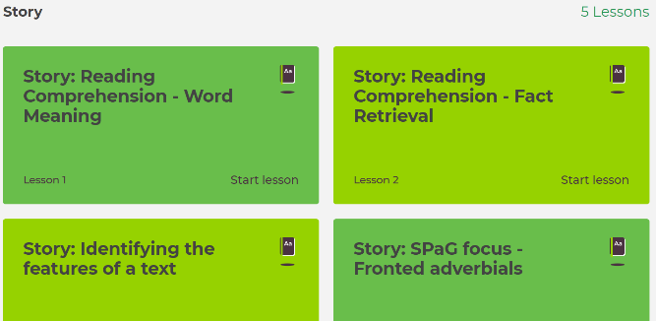
National Oak Academy
https://classroom.thenational.academy/subjects-by-year/year-4/subjects/english/# Follow this link to find online lessons for the week. Complete the story lessons which will help with your descriptive writing task above. Make sure you are listening carefully as the teacher explains the tasks and activities to complete.

Reading
Complete the Reading Comprehension tasks on the blog and there are answers for them as well. I have attached Year 3, 4 and 5 reading comprehensions so you can all challenge yourselves.

Maths Tasks

Head to Mathletics and complete some of the activities. There are a range of activities and games that you can play to develop your Maths.

Take on the challenges on TT Rockstars and see what score you can get. Good luck!

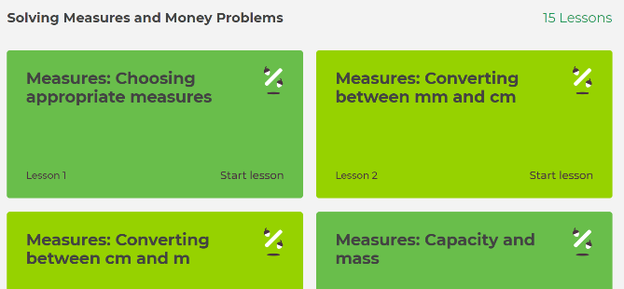
National Oak Academy https://www.thenational.academy/online-classroom/year-4/maths/#subjects Follow this link to complete work on Measures and Money Problems. There are 15 lessons that you can complete throughout the week and make sure you are listening carefully as the teacher explains the tasks and activities to complete.

Complete the Pounds and Pence Worksheets. Use the accompanying Powerpoint to help and guide you first. These sheets are differentiated and would normally take 1 to 2 lessons to complete. There are extension activities to be completed as well as answer sheets.

Complete the Ordering Money Worksheets. Use the accompanying Powerpoint to help and guide you first. These sheets are differentiated and would normally take 1 to 2 lessons to complete. There are extension activities to be completed as well as answer sheets.

Theme Tasks

Use the Powerpoint, ‘Where does our Water come from?’ as well as a map to answer the UK Rivers activity sheet. There are 3 different challenges that you can choose from, as well as an answer sheet for you to check.

This week it is Father’s Day, so why not create a card for your Dad, Grandad or a loved one in your family. Use any craft objects you have at home to be as creative as you can!

Take a look at ‘Joyful June’ and complete some of the activities on there. Take is as Day 1 and move through the month to enjoy the different activities!

Science Tasks

Use the Exciting Electricity Powerpoint and the Mind Map you created last week, to create an information sheet about electricity and how it is created. Design it to help you remember the key parts of electricity and what others would want to know.

Use the Appliances Powerpoint and sort the appliances in to whether they need to use electricity or not. You could draw the pictures rather than printing the sheet out, then you can be as creative as you would like to be!

Decide whether your appliances need a battery or not and sort them into the different categories using the ‘Mains or Battery’ sheet. How many of those appliances can you find in your house? Have you got any other appliances that use electricity, whether that is mains or battery? Add them to your sheets and decide where they will go.

Ongoing Weekly Tasks

BBC Bitesize- They have released some great lessons with teachers that the children can access and follow through independently.
TT Rockstars- Online timestable practise. Check out the battles on there! Who will win, the boys or girls?
Mathletics- You should have your login details from ClassDojo so login and complete some of the work set and play some games. I will add more things on here throughout the week.
Oxford Owl – Online ebooks which match your child’s reading book band.
Classroom Secrets – Online activities that your child can access.
White Rose Maths- This is the scheme we follow in school and they continue to update it with activities that can be completed at home.
Spelling/phonics- related to your year group or what you are covering in school.
ICT Games – Interactive Maths and English games.
Once Upon a Picture – A selection of interesting images which can inspire your child to write. It could be a story, a recount, a set of instructions, whatever motivates your child.
Roy the Zebra – Interactive reading games.
Topmarks - A range of interactive activities for all subject areas throughout the curriculum.

