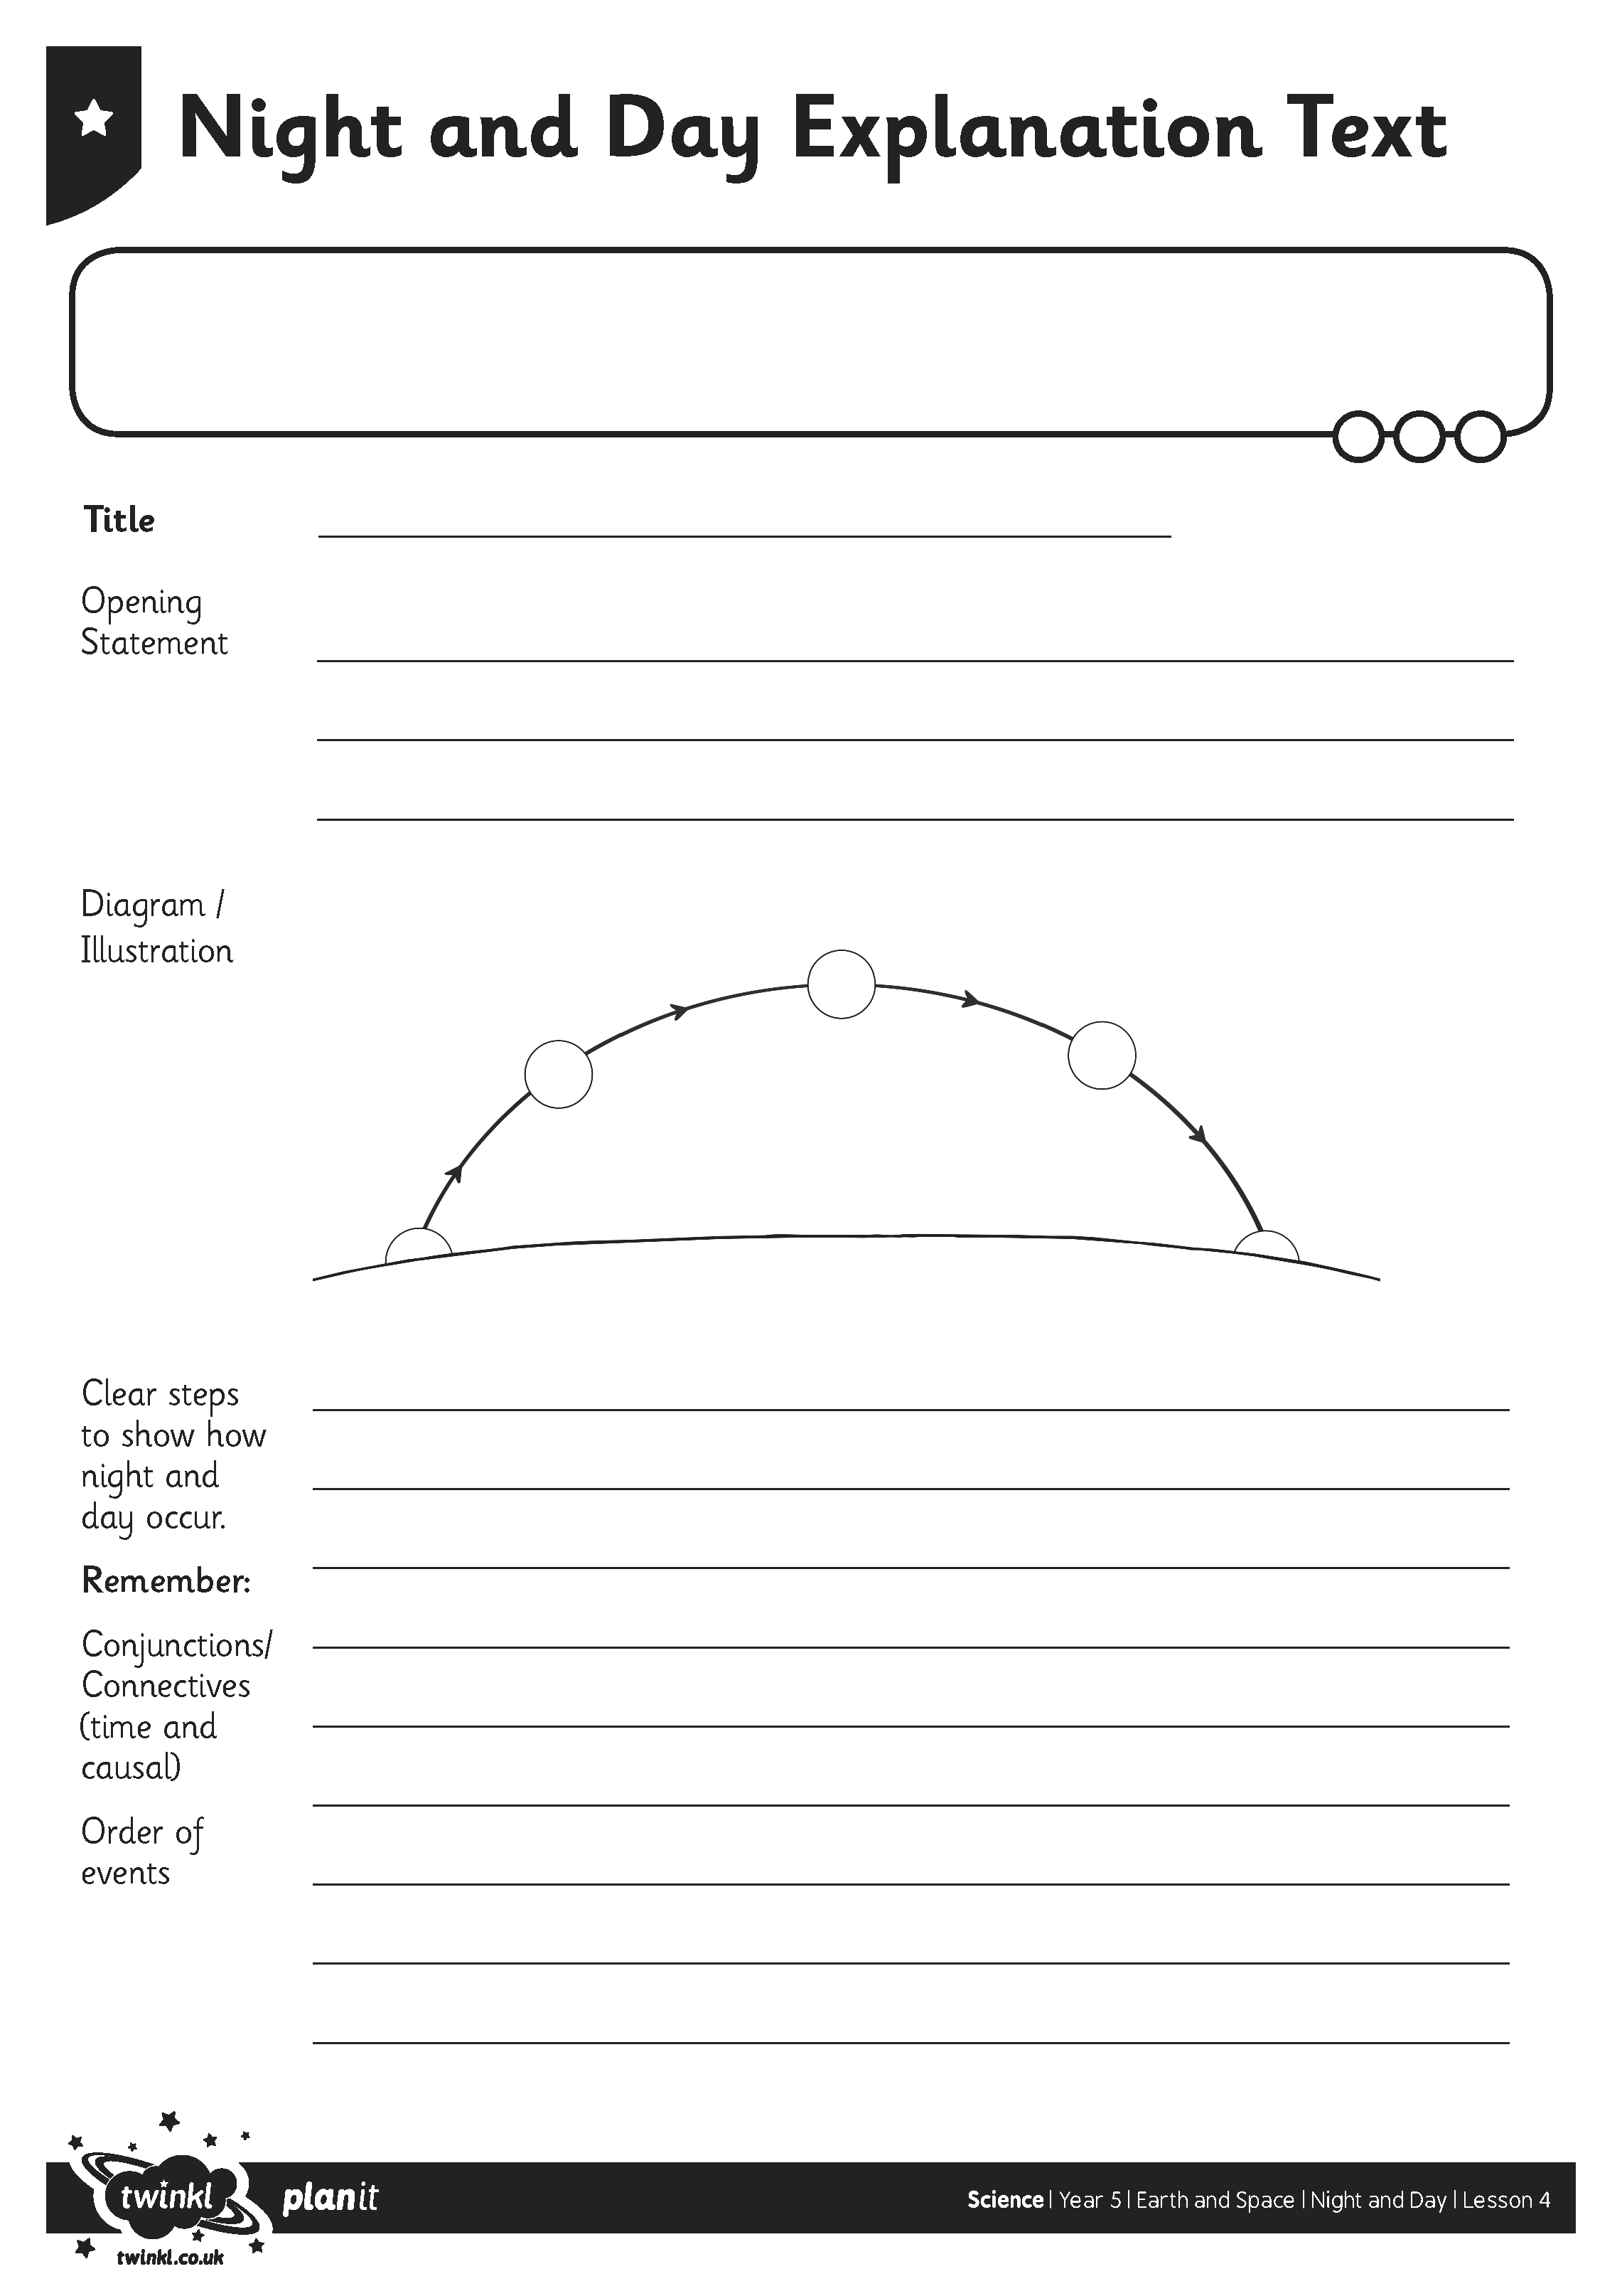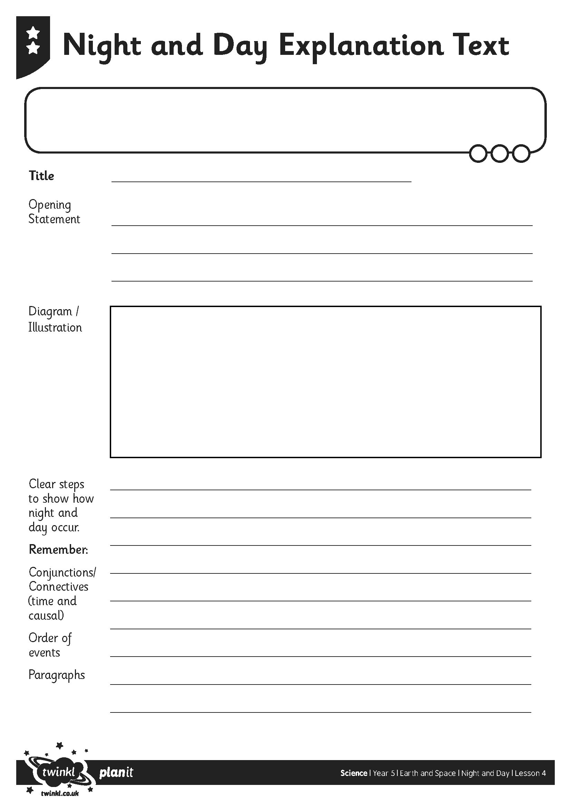
I can explain day and night and the apparent movement of the sun across the sky.
I can identify scientific evidence which does or does not provide evidence for an idea or argument.
I can explain day and night and the apparent movement of the sun across the sky.
I can identify scientific evidence which does or does not provide evidence for an idea or argument.

