**KS2 Writing activity**

This week we are going to learn about Captain Tom and the amazing effort he has put in to help fundraise for the NHS.

We are going to write a letter to say a big ‘THANK YOU’ to him for helping everyone who is having a hard time at the moment.

Before we start, we need to find out some information about Captain Tom:

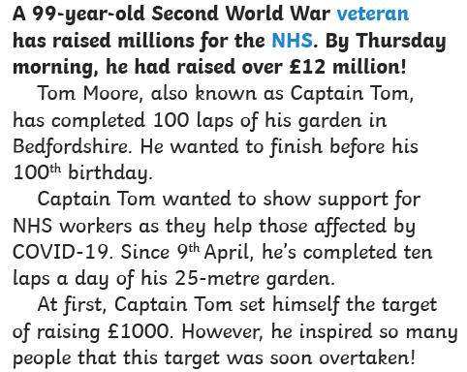

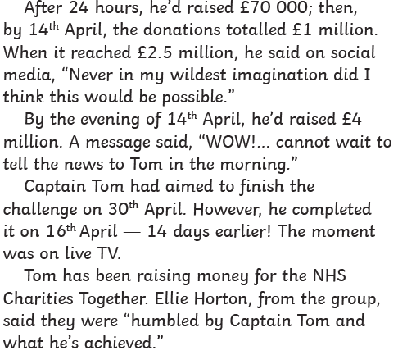

Here is a picture of Captain Tom Moore. We call him Captain because he was in the army and held a position of leadership.

Can you believe he is nearly 100 years old? He has lived through so many changes in our world- one World War, countless new technology and even the forming of new countries!

Now we know a bit more about Captain Tom, we are going to write a letter to him to say thank you for walking 100 laps.

We are going to start by thinking about what we need to put into our letter.

Answer these questions:

1. What is our main message for Captain Tom?

…………………………………………………………………………………………………………………………………………………………………………………………………………………………………………………………………………………………………………………………………………………………………………………………………………………………………………

1. What are the key facts about what Captain Tom did?

…………………………………………………………………………………………………………………………………………………………………………………………………………………………………………………………………………………………………………………………………………………………………………………………………………………………………………

1. When is Captain Tom’s birthday – why is it so special?

…………………………………………………………………………………………………………………………………………………………………………………………………………………………………………………………………………………………………………………………………………………………………………………………………………………………………………

Now we are ready to write our letter to Captain Tom to say thank you for all the money he has raised to help us.

Use the letter template below to help you write your letter.

Success criteria- what you need to include to write a successful letter:

Your address

Today’s date

A greeting to Captain Tom (Dear Captain Tom etc)

Sign off (from you)

Paragraphs to show a new subject

Sign off (Best wishes etc)

Correct sentence punctuation (capital letters, full stops etc)

Adjectives to show your emotions (I’m so grateful!)

Your address

Today’s date

Dear …………………………………………………..

Paragraph 1: …………………………………………………………………………………………………………………………………………………………………………………………………………………………………………………………………………………………………………………………………………………………………………………………………………………………………………………………………………………………………………………………………………………………………...................................................................................................................

Paragraph 2:

………………………………………………………………………………………………………………………………………………………………………………………………………………………………………………………………………………………………………………………………………………………………………………………………………………………………………………………………………………………………………………………………………………………………………………………………………………………………………………………………………………

Paragraph 3: …………………………………………………………………………………………………………………………………………………………………………………………………………………………………………………………………………………………………………………………………………………………………………………………………………………………………………………………………………………………………………………………………………………………………

Sign off:

………………………………………………………………………

When you have written your letter, have a look through and check what you have written.

Have you included:

Your address

Today’s date

A greeting to Captain Tom (Dear Captain Tom etc)

Sign off (from you)

Paragraphs to show a new subject

Sign off (Best wishes etc)

Correct sentence punctuation (capital letters, full stops etc)

Adjectives to show your emotions (I’m so grateful!)

If not, go back and see where you can add them in.

You may want to re-write your letter as your second draft – this would help you to edit and improve what you have already written.

Take a photo of your letter and send it to me, I am really looking forward to seeing what you have written!

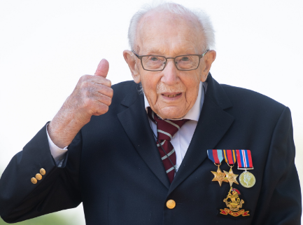Thank you Captain Tom from everyone at Ellingham! We really appreciate everything you have done- you are a hero in every sense of the word.