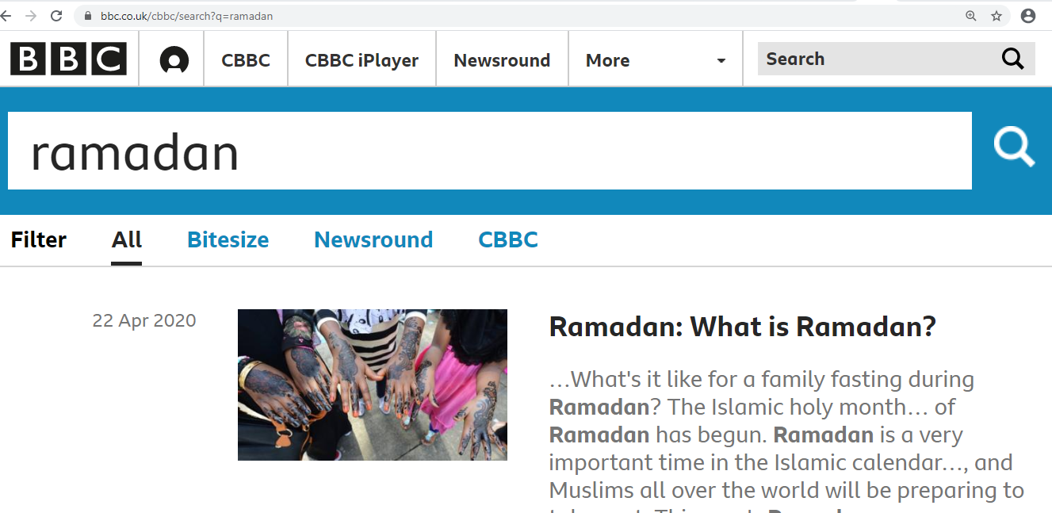

Take a look at BBC for videos about Ramadan to watch. <https://www.bbc.co.uk/cbbc/search?q=ramadan>